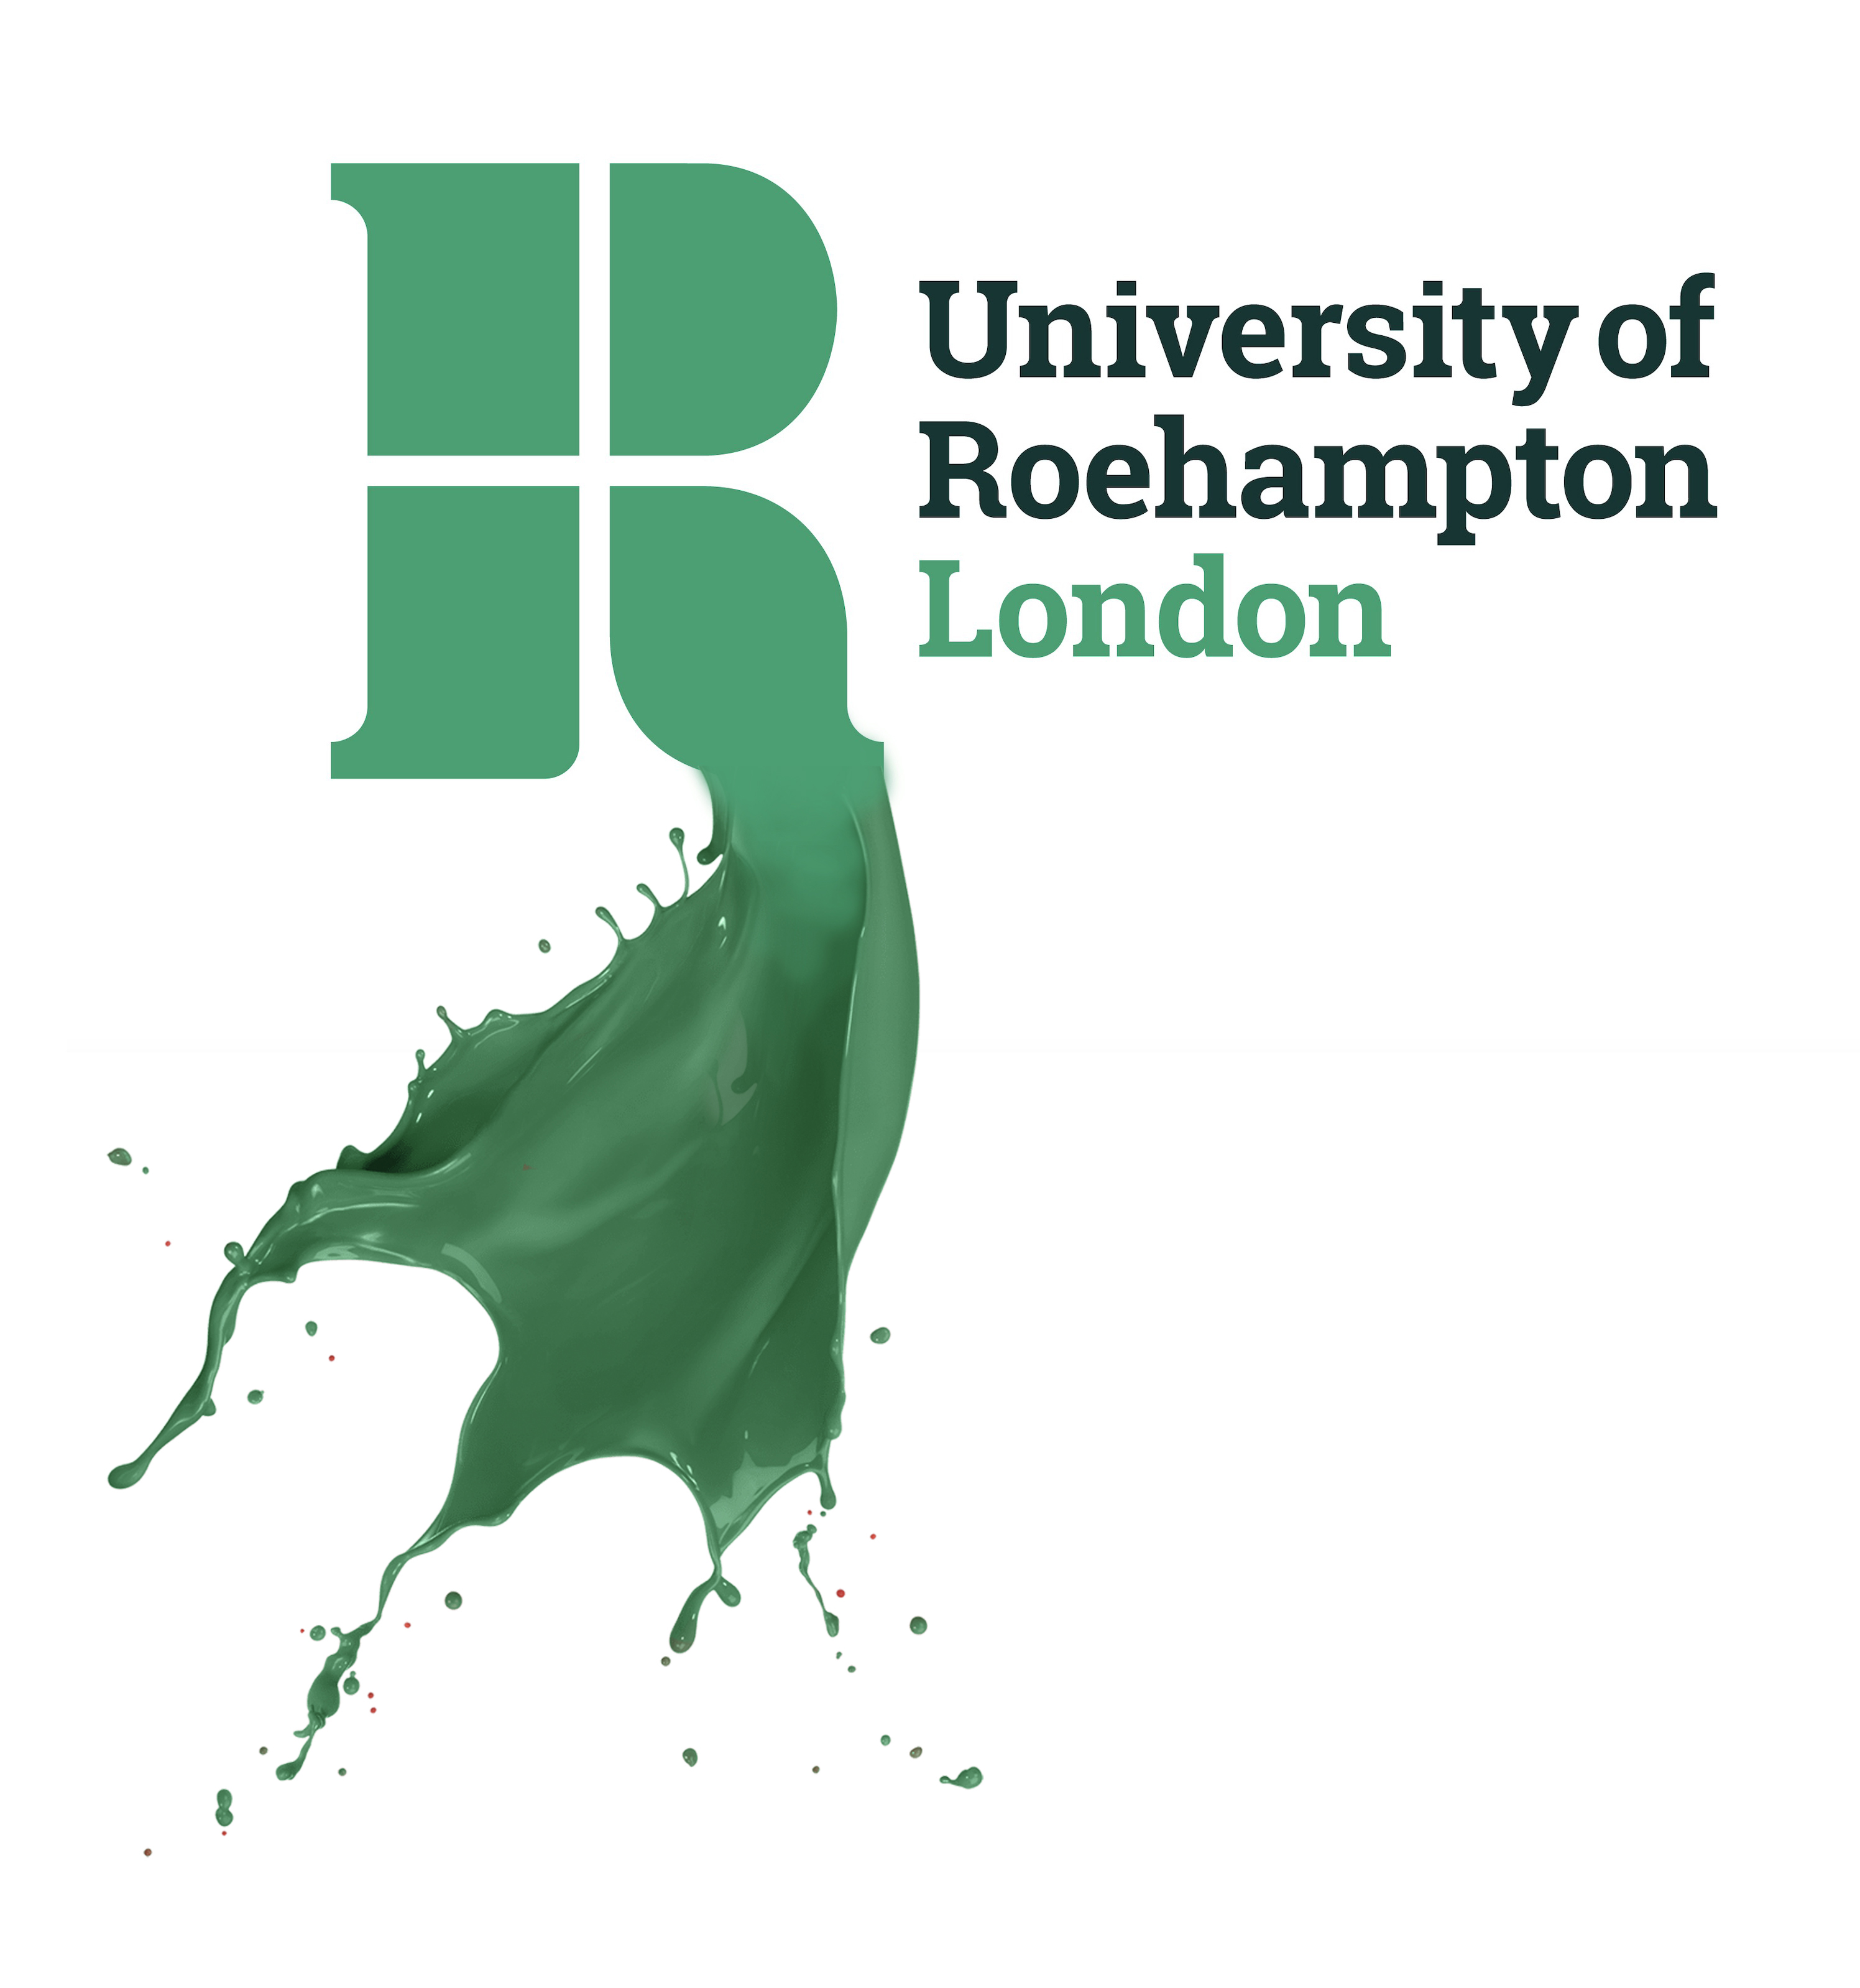

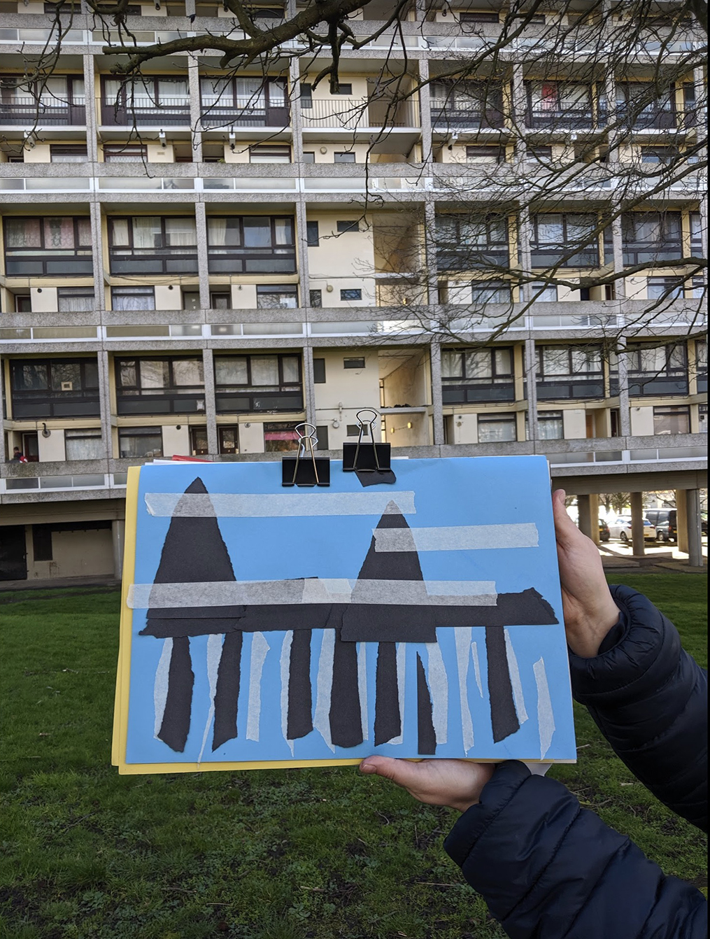

PGCE Secondary Art and Design
Subject Studies Handbook 2022-23

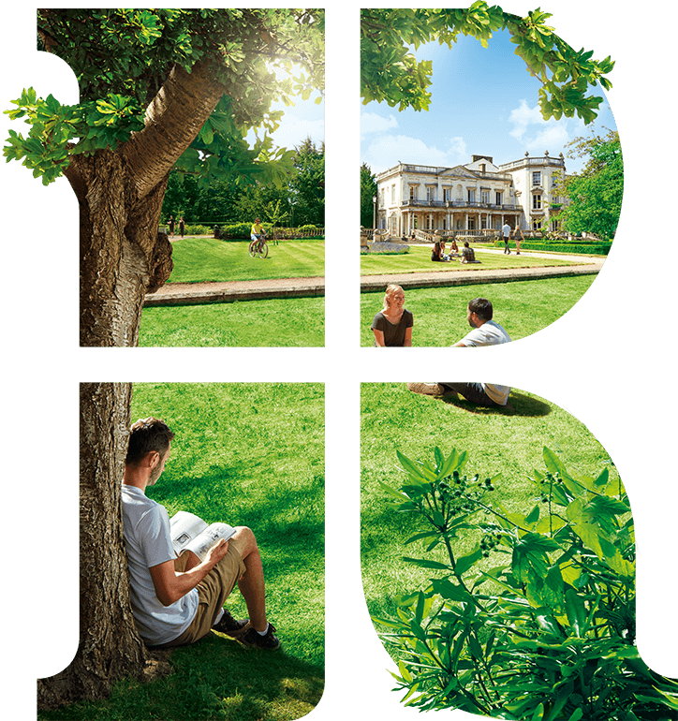

School of Education ethos

Roehampton teachers are:

Respectful:
We respect each other and build positive relationships with our pupils and colleagues. We celebrate diversity and create an inclusive community.

Reflective:
We reflect on our practice, connecting academic literature, research, and school experience. We strive to continually improve our pedagogy.

Resilient:
We support each other and seek to grow from our challenges.
We strive to realise our potential and to thrive together.

Resourceful:
We work hard, and we are creative, imaginative and curious. We keep learning.

A Frobelian, child centred approach to teacher education, with the pastoral
and learning needs of the whole student and child at its core.

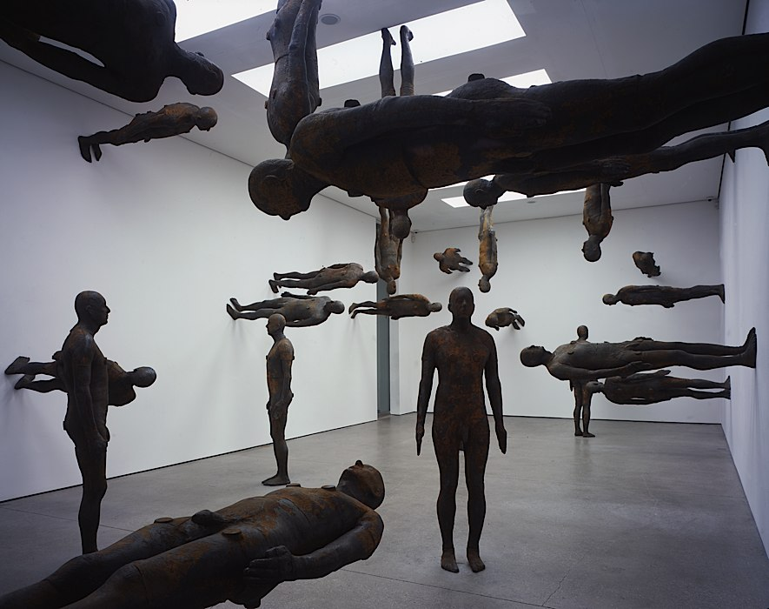

Antony Gormley: Firmament White Cube Mason's Yard, London, 2008

Perhaps the most important argument for the centrality of art in education is
that the art room can become a zone dedicated to the exercise of curiosity, a
place where the instincts of questioning can find their own paths to language.
What happens when I mix this with that? How does what happens affect me?
How does it affect others?

There is an implicit injunction in the art room to take responsibility for the
experiments the individual makes because she has chosen to make them;
and when that focusing on response is sharpened by the sharing of the
intentions of the maker and the perceptions of peer perceivers, the individual
can both give form to and gain an appreciation of the value of a unique contribution
to the world, allowing her to become an active maker of a living culture, rather
than a passive consumer.

It does not matter whether the individual ends up becoming a professional artist:
the important thing is that the direct experience of art makes the individual.

Antony Gormley (Hickman 2010)

PGCE Secondary Art and Design Subject Studies Handbook 2021-22

Contents Page
Welcome and Introduction 5
Teaching team and contacts at Roehampton 5

Teaching and learning methods 6

Organisation 7

Module 1 (Autumn Term) 8

Module 2 (Spring Term) 10

Assignment marking criteria 12

Subject Sessions at a glance 15

Overview of subject sessions for Students and Mentors 18

Bibliography 36
Museums and galleries (websites) 40

Welcome to the PGCE Secondary Art and Design course at Roehampton.

As you begin your journey into teaching you will work with many inspirational people, including your school mentors and fellow students in your subject and Professional Studies groups.

The PGCE Secondary programme aims to provide students with a rich, cohesive and personalised experience of initial teacher education. We want to enable you to fulfil your potential as teachers and to experience an engaging, stimulating and enjoyable year. I hope you enjoy making the most of the opportunities on offer during the year and I look forward to working with you at Roehampton, in partnership schools and through online teaching sessions.

Dr. Robert Watts

Senior Lecturer in Art and Design Education

Lulham 003 | University of Roehampton | London | SW15 5PJ

r.watts@roehampton.ac.uk www.artandeducation.co.uk 020 8392 3871

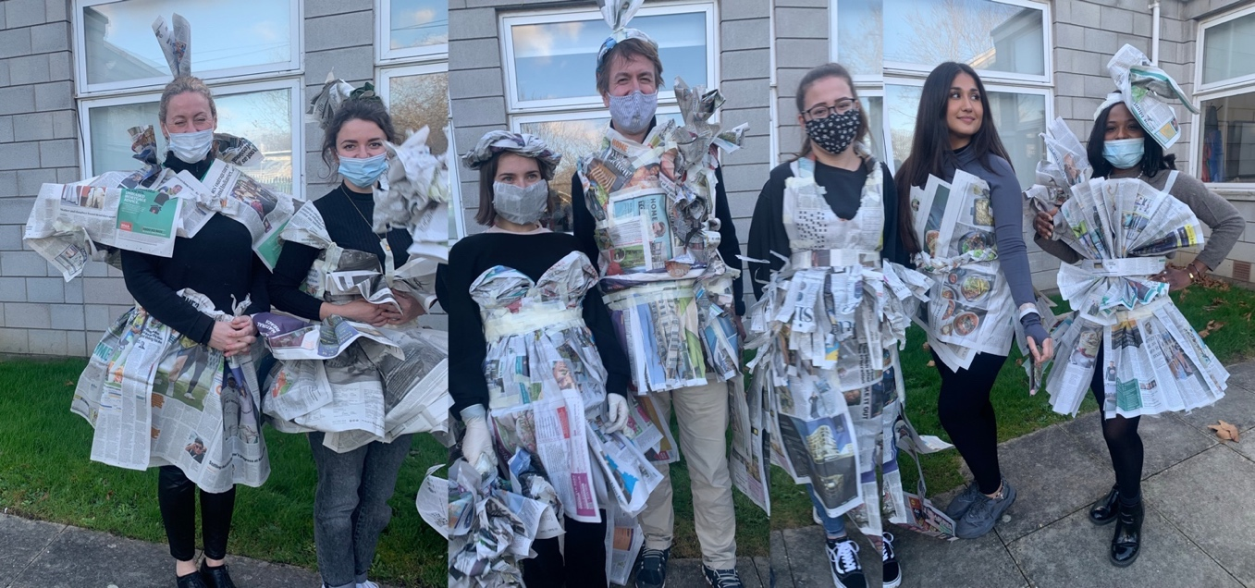

Teaching team and contacts at Roehampton:

School based colleagues are also involved in teaching university sessions including staff from many placement schools and will enable you to observe excellent teaching through learning rounds in schools.

School mentors. We are very fortunate to have an extensive range of experienced and inspiring mentors, an essential element in our successful partnership. Building positive professional relationships in schools is the best foundation for a successful career, and is fundamental to meeting the Teachers Standards.

Roehampton Subject Tutors contribute towards taught sessions in the spring and summer terms, as well as carrying out some supervision of school placments.

Programme Convenor: Alison Messer Cedar 001, Lulham Building Froebel College 0208 392 3106 A.Messer@roehampton.ac.uk

Disability Services – Richardson Building
Students with disabilities should contact staff here to discuss what support in their studies, exams or the Library might be useful. If you suspect you may need support for dyslexia you can arrange appointments for assessment and to discuss academic support. disabilities@roehampton.ac.uk 0208 392 3636

Student Funding Office
Information related to Student Loans, Bursaries and Scholarships is available as well as advice on applying for the Access to Learning Fund (ALF). Tel: 020 8392 3082 or 3090
studentfunding@roehampton.ac.uk
http://www.roehampton.ac.uk/Finance/Student-Funding/
http://www.roehampton.ac.uk/Finance/Postgraduate-Finance/

Health and wellbeing advice and counselling:
If you are experiencing emotional difficulties you may also contact the Health and Wellbeing drop-in service (term time Wednesdays 2pm to 4pm) in the Student Services Advice Centre. Tel: 020 8392 3668
health&wellbeing@roehampton.ac.uk
In a medical emergency you should go straight to the Student Medical Centre, which is located in Old Court, Froebel College (020 8392 3679).
FOR ADVICE RE. COVID-19 PLEASE VISIT:
https://portal.roehampton.ac.uk/student/Pages/Home.aspx

This booklet outlines the Art and Design component of the PGCE Secondary course. It should be read in conjunction with the online PGCE guide, Professional Studies booklet and the How to guide, which explains roles and responsibilities on placement, and how your progress towards QTS is recorded on the Abyasa system. Updates are posted on the Art and Design and Professional Studies (PS) Moodle sites and on the PGCE Secondary Moodle Hub:

Art and Design https://moodle.roehampton.ac.uk/course/view.php?id=9244
Professional Studies https://moodle.roehampton.ac.uk/course/view.php?id=9255
Subject module 1 (20 M level credits) is assessed by Assignment 1.
Subject module 2 (20 M level credits) is assessed by Assignment 2.
Professional Studies (20 M level credits) is assessed by Assignment 3.
Teaching Experience module (60 professional level/Category P credits).

See also https://www.gov.uk/government/publications/teachers-standards for information about the Teaching Standards that you must meet before you can qualify.

Teaching and learning methods

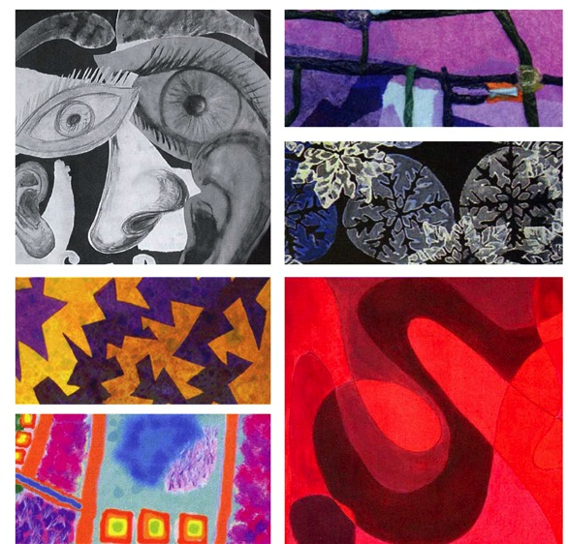

The course uses a variety of university-based and online teaching and learning methods. These aim to help you meet the programme learning outcomes and to offer opportunities to share strategies and expertise you have gained through your experience in school. Subject sessions will explore skills and approaches that facilitate effective learning in Art and Design. The key aim of these sessions is to draw links between theory and practice in art and design education.

You will be encouraged to use collaborative and autonomous methods including:

- Lectures and tutor-led presentations - these offer opportunities to explore a range of key concepts and ideas. These take place both online and onsite;
- Workshops - these allow you to develop your skills, knowledge and understanding through a range of practical activities;
- Learning rounds in partner schools - these allow you to observe expert teaching and to analyse how teachers create effective learning opportunities for pupils;
- Discussion - opportunities to exchange views and develop your ability to think independently as professionals;
- Directed tasks, self-directed study and individual research. These tasks are related to the course syllabus and assignments and are completed outside contact hours;
- Tutorials - both group and individual - provide specific advice, guidance and support in relation to the course and school experience;
- Moodle - Our online learning environment is an essential part of the course, used to exchange information, resources, ideas and concerns throughout the course. It is also by tutors to make the connection between practice and research literature whilst in university and on placement.

Organisation

Timetable
You will be in school for much of the time on your course, observing, supporting and leading teaching and learning, and in university for 20 subject days and 14 Professional Studies days. Some teaching sessions in 2021-22 are likely to be taught online. Teaching sessions are on most Wednesdays, starting at 9:30am and finishing at 4:30pm.

Directed Tasks
You are expected to make effective use of time outside of the taught sessions and the school timetable. There are a small number of days during the year when you need not be in school or university and you will be set directed tasks to complete during these days.

Attendance
Although lecture and workshop materials will be available online, you should understand that attendance at taught sessions is essential – there is no substitute for being there! For example, a presentation might feature an artwork but it cannot capture the discussion that the artwork stimulated in the lecture. If you are unable to attend a session please email or telephone before it begins. You must also inform your Professional Studies tutor if you are unable to make a PS session.

Information and Communications Technology (ICT)
You will need to have your own computer or access to one. All assignments should be word-processed and you are expected to use computers for record keeping, lesson planning and developing classroom materials. The School of Education has two computer suites close to the art room in the Lulham Building, which are available to students when they are not booked for teaching, and there are additional, extensive facilities in the Library.

Resources
Various resources are kept in the art and design room. You are welcome to use them and some may be borrowed through our technician, Maxine Venes (maxine.venes@roehampton.ac.uk)

Moodle
Moodle is the virtual learning environment used by all Roehampton students. You will be introduced to the subject site in the first week of the course and use it to access resources used in sessions, school materials, items posted by other students, etc. The three Moodle sites should prove to be valuable resources for your teaching in school as well as for your assignments.

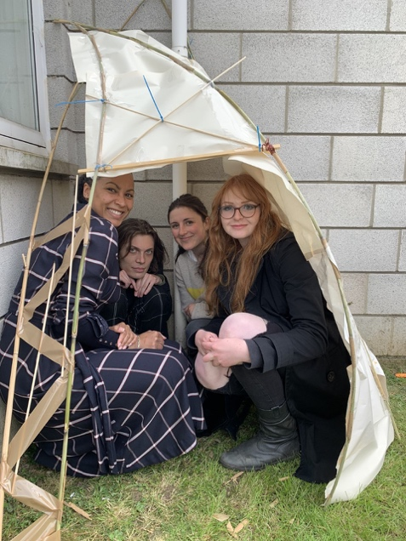

Module 1 (Autumn Term)
Rationale
This module introduces the theory and practice of Art and Design in schools. You will reflect on the aims and nature of teaching and learning in Art and Design and focus on the principles for teaching the subject. You will share your previous experiences of teaching and learning in art and design and reflect on how these influence your approach to teaching.

You will explore the core practical processes of drawing, painting and printmaking. You will begin to develop the knowledge, understanding and skills required to plan, resource, manage and teach appropriate and effective lessons.

Learning Outcomes
Students who successfully complete this module will have:
- audited their existing knowledge and skills and identified developmental needs
- begun to develop a critical awareness of some of the current debates surrounding the values, purposes and content of art and design in schools and be able to relate these to classroom practice;
- observed and analysed the impact of their own and others’ teaching on pupils’ learning,
- made connections between theories of learning in art and design and their own practice in schools.
- broadened their knowledge and appreciation of the place of art and design within the curriculum
- begun to develop an understanding of how pupils learn and make progress in the subject
- developed personal and social skills and attitudes relevant to teaching, such as communication skills and the readiness to respond to advice;
- made progress towards meeting the Teachers’ Standards.

Module 1 Assessment: 3500-word essay

Title: Values in art and design education

Aims:

- to write a literature review that reflect on the values for art and design education identified by a selection of authors (Part 1)

- to write a reflective piece that identifies:
  - your own values for art and design education;
  - how these values relate to the texts referred to in your literature review;
  - how these values have impacted on your development as an artist/craftsperson/designer in the past
  - how these values are beginning to impact on your teaching of art, craft and design. (Part 2)
The first half of the essay is rooted in theory. You should analyse authors’ values in art and design education, drawing on core texts and additional material. The second half is practice-based. It is an opportunity for you to reflect on your own experiences as a teacher and learner in art and design in the context of the theories you have explored, in order to demonstrate your growing understanding of how and why you want children to learn in art and design.
First submission: Draft Literature Review - due October 29th 2022 via Turnitin
You are asked to submit a draft version of your literature review on this date. You will receive formative feedback on this draft that will enable you to edit and improve the literature review and to enhance your writing at Masters’ Level. You will then continue with the second part of your assignment, using your reading to critically reflect upon your own values and what you have seen and experimented with in school. You could also observe children’s approaches to learning in art and design, and critically reflect on pedagogical strategies teachers adopt in school to address them.
The recommended texts for this assignment are listed below and you will find a list of further literature at the end of this booklet. You will be given formative feedback on this review, and you can use the feedback to extend your reading, and deepen your levels of critical reflection.
Final submission: 4pm, January 5th 2022 via Turnitin
Module 1 (Autumn Term) – (Continued)

Essential texts

Addison, N. and Burgess, L. (2014) (Eds.) Learning to Teach Art and Design in the Secondary School: A Companion to School Experience (Third Edition) London: Routledge Falmer
Eisner, E. W. (2004) The Arts and the Creation of Mind New Haven: Yale University Press
Hickman, R. (2010) Why we make Art and Why it is Taught (Second Edition), Bristol: Intellect

Links to all readings are available on Moodle. The course resource list is available here:
https://rl.talis.com/3/roehampton/lists/8FFDEB60-8C7D-7C26-E57A-8BAF3260B1F2.html

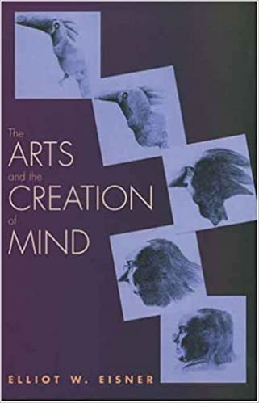
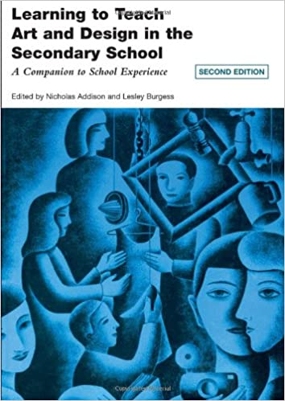
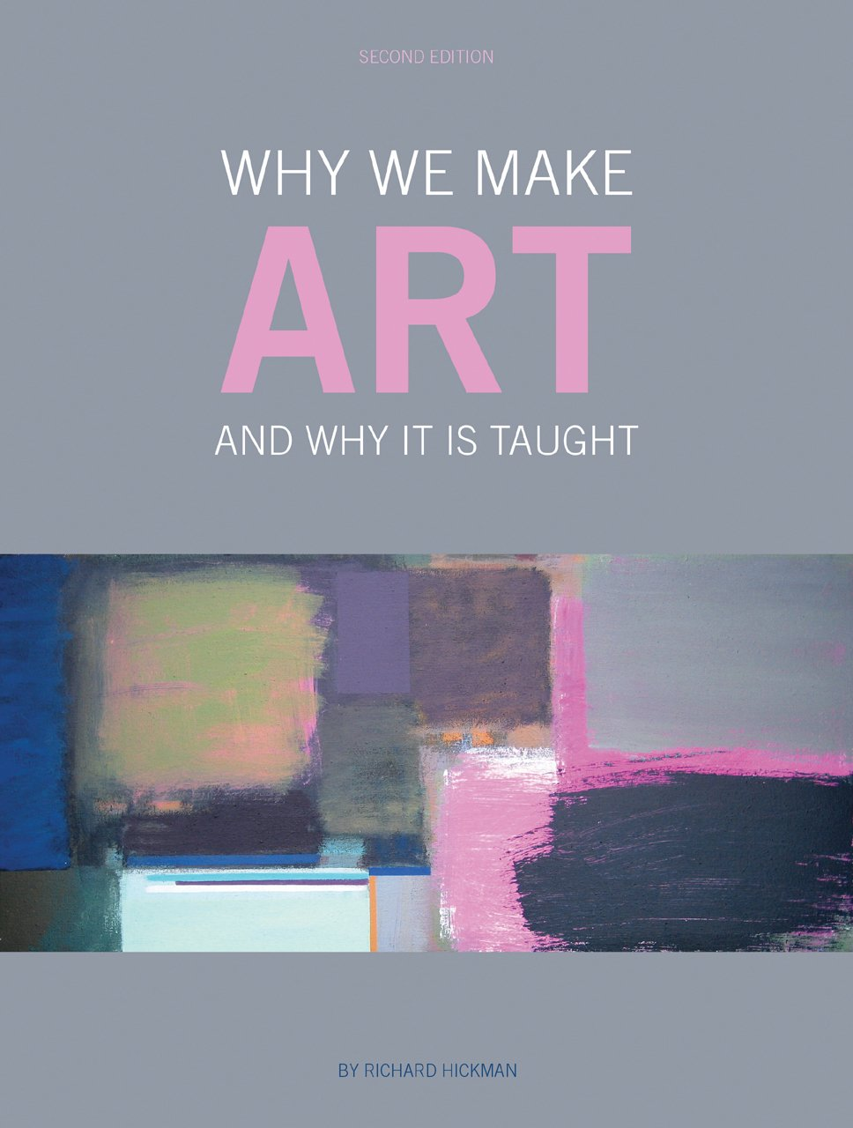
Module 2 (Spring Term)
In this module you will extend and consolidate your subject knowledge and teaching skills in the light of your previous and continuing school and university experiences. You will develop further the knowledge, skills and confidence required to plan, manage and teach appropriate and effective lessons that meet the needs of all pupils.
You will achieve this by implementing a wider range of planning, teaching and assessment techniques and making fuller and more targeted use of assessment information. You will learn about, research and evaluate a broader range of approaches to learning and teaching and use this knowledge to challenge your thinking and experiment with alternative strategies.
The module will encourage you to take responsibility for your on-going professional development; to reflect on and evaluate your school experiences in order to identify your strengths, interests and areas for future development.

Learning Outcomes

Students who successfully complete this module will:
- have consolidated the knowledge, understanding, values and skills necessary to become effective teachers within the KS3-KS4 age range;
- have developed their understanding of assessment processes;
- enhance their understanding and professional practice through research, analysis and reflection
- developed their knowledge of theories and principles underpinning classroom practice in art and design, including awareness of research literature
- developed the skills, knowledge and understanding needed to assess, progress, record and report pupils’ achievement and attainment in Art and Design
- have evaluated their own performance and have identified areas of strength, interest and development needs as they prepare for the NQT Year;
- have met the Teachers’ Standards above the minimum level for recommendation for Qualified Teacher Status
- develop creative visual teaching resources demonstrating their knowledge and understanding of critical and contextual studies and museum and gallery education;
- develop their knowledge and skills in ICT and have begun to appreciate the role it plays in supporting Art and Design Education;
- understand and implement a range of ways in which pupils' progress can be assessed, recorded and further used to inform planning;

Assessment: 3500-word essay. Submission by 4pm, 8th April 2022

Title: How does teacher assessment of children’s work help to improve their knowledge and understanding of Art and Design?

Key aim:

This assignment will require you to reflect on the nature of assessment and investigate children’s progress in Art and Design

Further aims:

- To demonstrate how the literature has informed your understanding of broad issues surrounding assessment in secondary schools

- To select a specific form of assessment and critically review literature related to it

- To consider how assessment of children’s work can help improve their knowledge, understanding and technical skills in Art and Design

- To choose an aspect of Art and Design to explore through a sequence of 4-6 lessons

- To reflect on how your chosen form of assessment helped to promote pupil progress in relation to your chosen aspect of Art and Design
Module 2 (Spring Term) (continued)

Recommended texts
Hardy, T. (2006) Art Education in a Postmodern World Bristol: Intellect
Hickman, R. (2004) (Ed.) Art Education 11-18: Meaning, Purpose and Direction (Second Edition) London: Continuum
Rayment, T. (2007) The Problem of Assessment in Art and Design Bristol: Intellect

Links to all readings are available on Moodle. The course resource list is available here:
https://rl.talis.com/3/roehampton/lists/8FFDEB60-8C7D-7C26-E57A-8BAF3260B1F2.html

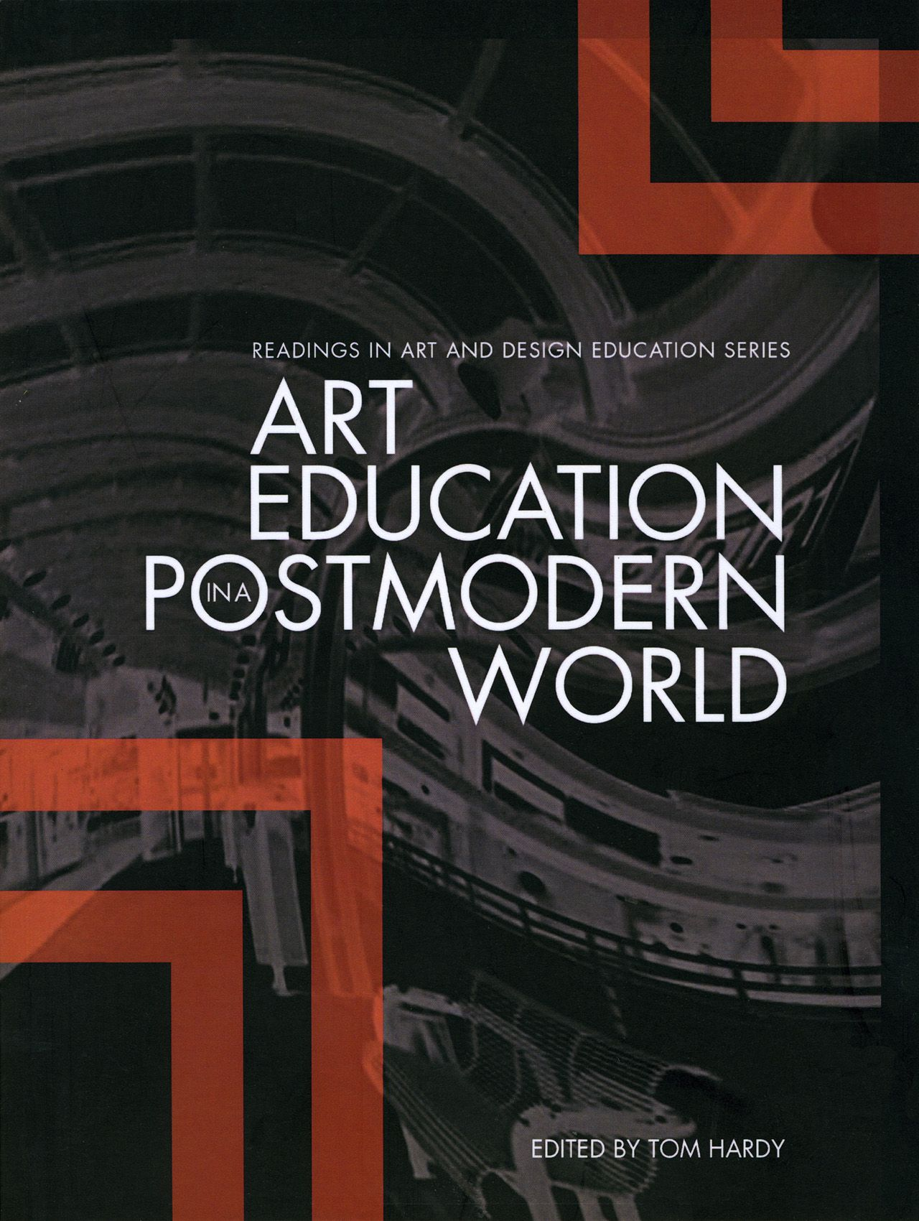
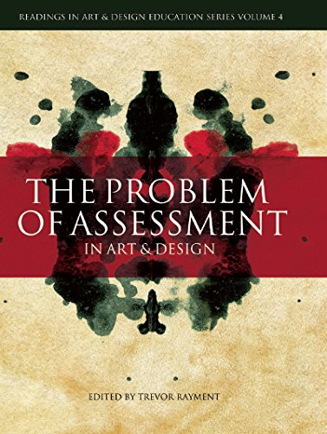
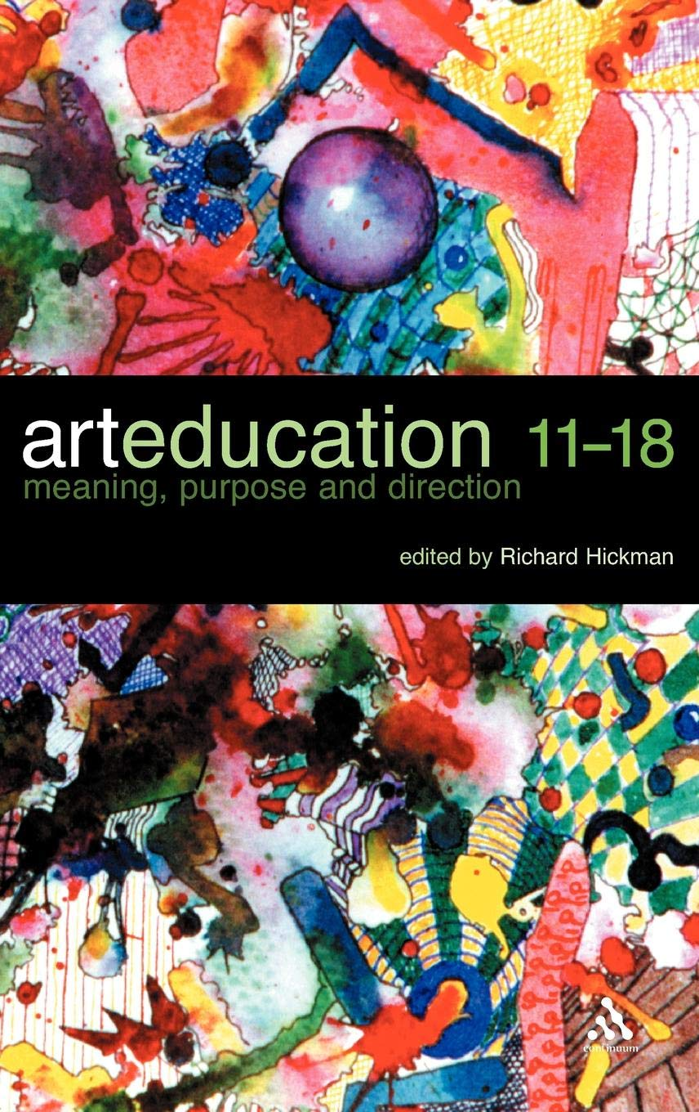

Assignment marking criteria

All three assignments will be marked against the criteria below. As a minimum requirement, students must achieve a pass grade in all written assignments as assessed against the M-level criteria as set out in this document.
Accurate referencing, alphabetical bibliography, evidence of appropriate reading including research, use of school experiences to support debate; reference to how the work contributes towards meeting the Teachers’ Standards for QTS.

 | Dimensions of knowledge, understanding and skills to be assessed
Grade range | Learning relating to module aims and outcomes | Range and understanding of literature, key concepts and theories | Analysis of key focus, using theory | Communication, structure and presentation
80-100  Outstanding piece of work | As below. | As below, plus:  A comprehensive integration of relevant literature and analysis | A sophisticated critical theorisation and/or innovative conceptualisation of the key focus and related issues. For example, the work shows iterative processes of critique, including critical analysis of theory using practice and/ or other theory, and a further critical analysis or the generation of models drawing upon that analysis.  Achieves an outstanding critical insight into the key focus and related educational issues. | As below.  Outstanding bibliography with academic referencing conventions employed accurately, consistently and according to established practice within the discipline. Conforms to the highest standard that can be reasonably expected from a Masters’ level submission.
70-79  Distinctive standard | A sophisticated and comprehensive engagement with module aims and attainment of learning outcomes. | Authoritative grasp of a very good range of relevant literature, and in-depth understanding of concepts and theories demonstrating an integration of relevant literature and analysis. | Theory is used to analyse school experiences and practices in a systematic and in-depth way, and the analysis is clear, coherent and critical, providing insight into complex issues. | Very good organisation, a precise writing style, and presented in standard English.  A high standard of referencing throughout. Bibliography conforms to a high standard, though there may be a number of small errors which can be easily corrected in future submissions.
60-69  Merit standard | A clear and systematic engagement with module aims and substantial attainment of learning outcomes. | Good understanding of relevant literature, key concepts and theories and good use is made of a range of sources. | Theory is applied to school experiences and practices in a systematic way, and the analysis is clear, coherent and consistent. | Good organisation, a clear writing style, referenced well and presented in standard English.  A good standard of referencing, though a number of errors or inconsistencies may be present. Good bibliography but possibly containing technical errors, some minor, some more serious.
50-59  Pass standard | Engagement with the module aims and attainment of learning outcomes. | Sound understanding of relevant literature, key concepts and theories and appropriate use is made of sources, though these may be limited. | Theory is applied to school experiences and practices, for example through reflection, explanation or evaluation and the analysis has some clarity, coherence and criticality. | Appropriate organisation, an appropriate writing style, is presented in standard English. . Referencing barely satisfactory. A number of inconsistencies in citation may be present. A narrow pass if satisfactory bibliography with some serious weaknesses in composition and use of referencing conventions.
40-49  Fail standard | Very limited engagement with the module aims and attainment of learning outcomes. | A basic understanding of relevant literature, key concepts and theories. Use of literature sources very limited. | Analysis is largely descriptive and lacking in clarity and coherence. | Lacks appropriate organisation and structure, is presented in non-standard English. Citations may be present, but referencing is poor, suggesting that little effort has been made to follow guidance. Work is vulnerable to unwitting plagiarism. Bibliography inadequate. Many errors, some serious, revealing an insufficient awareness of mechanics of scholarship.
0-40  Fail standard | Fails to engage with the module aims, and learning outcomes are not attained. | Lacking in conceptual content and / or the accurate and analytical use of appropriate sources. | Mainly descriptive, rather than analytical, and fails to make relevant links between theory and the key focus. | Unfocused, poorly organised. English is poor with errors of spelling, grammar and punctuation. Referencing is inadequate and fails to follow the required conventions.

Overview of Subject Sessions THIS IS THE 2021-22 VERSION – TO BE UPDATED!
Area of Professional Learning | Professional Behaviours | Pedagogy | Curriculum | Assessment | Behaviour Management
Standard | 8, Part Two | 2, 4, 5 | 3 | 6 | 1, 7

Date | Session focus | Areas of Professional Learning (APLs)
08/09 | Subject 1: Induction* for all students
09/09 | PS1: Professionalism and Behaviour Management
15/09 | Subject 2: Planning and Practicalities / Painting  PS Links: Professionalism (Wellbeing)
16/09 | PS 2: Learning & Memory/Well-Being @UR
22/09 | Subject 3: Introduction to Assignment 1 / Researching your assignment: engaging with the literature of art education  PS Links: Professionalism and Behaviour Management Wellbeing
29/09 | PS Hubs 3: Behaviour Management  (school policy and practice)
06/10 | Subject 4: Reflections on school experiences / Drawing, mark marking and collage  PS Links: Professionalism and Learning & Memory
13/10 | PS Hubs 4: Learning and Memory
20/10 | Subject 5: Researching and writing your literature review. Planning and teaching meaningful art and design activities  PS Links: Professionalism, Adaptive teaching
October half term – Hand in Part 1 Assignment 1 29/10/2021
03/11 | PS 5: Race in Education  Multilingual learners EAL @UR online (pm)
10/11 | Subject 6: Reflecting on influences in art and design (Part 1). Drawing  PS Links: SEND, Multilingual Learners PS Links: Behaviour management, Race in Education
17/11 | PS Hubs 6: SEND
24/11 | Subject Session 7: Writing Part 2 of your assignment – Your own values in art and design. / Reflecting on influences in art and design (Part 2)  PS Links: Learning and Memory
01/12 | Subject Session 8: Printmaking 1  PS Links: Cross-Curricular Learning
08/12 | PS Hubs 7: Assessment and Adaptive Teaching
15/12 | Subject 9: Assembling a portfolio for interview, gathering evidence and targets / Printmaking 2  PS Links: Interview Technique
Winter Break - Assignment 1 Hand in 04/01/2021
05/01 | Subject 10: Assessment 1 / Introduction to Assignment 2/ Sculpture  PS Links: Learning & Memory; Adaptive teaching & Assessment
12/01 | PS Hubs 8: Relationship & Sex Education  Behaviour Management revisited  Interview technique
19/01 | Subject 11: Digital learning in Art and Design: Photoshop / Geometry  PS Links: Cross Curricular Learning; numeracy
26/01 | PS Hubs 9: Research into Practice Conference
01/02 | PS Hubs 10: Pastoral Care
09/02 | Subject 12: Assessment 2 / Web design  PS Links: Adaptive teaching & Assessment; Learning & Memory
February Half Term
23/02 | PS 11: Assignment 3/ Voice Coaching
02/03 | Subject 13: Assessment 3 / Graphics  PS Links: Adaptive teaching & Assessment; SEND; Multilingual learners
09/03 | Subject 14: Children’s visual culture / Illustration  PS Links: Cross Curricular Learning; literacy
16/03 | PS Hubs 12: KS5 Transition
23/03 | Subject 15: Ceramics  PS Links: SEND; Adaptive teaching
30/03 | PS Hubs 13 – Cross Curricular Themes
Spring Break Assignment 2 Hand in 08/04/22
20/04 | Subject 16. Sculpture  PS Links: Adaptive teaching & Assessment; Cross-Curricular themes
27/04 | Subject 17: Museum and Gallery Education / Critical Studies / Photography  PS Links: Adaptive teaching & Assessment
Summer Half Term- Assignment 3 Hand in 31/04/2022
08/06 | Subject 18: Beauty and aesthetics in art education. Modernism and Postmodernism in art education / Textiles  PS Links: Adaptive teaching & Assessment; Voice coaching
15/06 | PS 14: TeenTech KS2- KS3 Transition Project
22/06 | Subject 19: BYCIT, Exit Survey / Reflections on outcomes in school  PS Links: Behaviour Management & Professionalism; Pastoral Care
29/06 | Subject 20: Revisiting principles for teaching and learning in art and design / Reflections on outcomes in school  PS Links: Behaviour Management & Professionalism; Pastoral Care

Overview of Subject Sessions for Students and Mentors
Date | Uni-Led and SD Subject Sessions (dates marked with * include SCITT students)
 | Foundation Phase
08/09 | Subject 1: Induction
15/09 | Subject 2:  Preparation: Research Mondrian’s journey from figuration to abstraction here  Preparation (for School Direct students only):  What have you learned from your first five days in school?  Come prepared with advice for Uni-led students.  If possible bring an example of a Medium-term Plan (scheme of work) from your school.  am: Planning and practicalities  - What should I expect in my first week/month in school?  - What are the challenges facing me?  - What should my priorities be?  - What do children want from teachers?  pm: Painting  - Meaning and purpose in planning practical activities  - Planning learning across a sequence of lessons  - Relating artistic knowledge to children’s experiences  Work individually:  - Take photographs that feature geometric compositions  - Select a photograph as inspiration for a sequence of three watercolours  - Explore the process of moving from figuration to abstraction  Work in pairs to create:  - an overview of a scheme of work (six lessons) inspired by Mondrian  - a single lesson plan developed from your scheme of work  - initial ideas for how other painters could inspire children’s thinking about their artwork  Recommend Reading (subject):  Some principles to guide practice in Eisner, E. W. (2004) The Arts and the Creation of Mind New Haven: Yale University Press  www.artandeducation.co.uk/painting  - Recommend Reading (CCF):  Coe, R., Aloisi, C., Higgins, S., & Major, L. E. (2014) What makes great teaching. Review of the underpinning research. Durham University: UK. Available at: What-Makes-Great-Teaching-REPORT.pdf (suttontrust.com)  PS Links: Professionalism (Wellbeing) Learning and memory

22/09* | Subject 3:  Preparation: See subject readings below  am: Introduction to Assignment 1  - How should you structure your assignment?  - What are the success criteria for the assignment?  Researching your assignment: engaging with the literature on the value of art education  - What are art educators perspectives on the value of art education?  - How do their principles and purposes compare and contrast?  Planning your assignment: getting started  - How might you plan your assignment?  - How will you begin your first draft?  pm: Identifying priorities for your first week in school.  - Reflect on your values in art education – think about your experiences as a learner both at school and university.  - Reflect on further advice for Uni-led students on starting your placement  Recommend Readings (subject):  - Hickman, R. (2005) Why we make art and why it is taught Bristol: Intellect (Section 1)  - Eisner, E. W. (2004) The Arts and the Creation of Mind New Haven: Yale University Press  (Chapter 3)  Recommend Readings (CCF):  Cowan, N. (2008) What are the differences between long-term, short-term, and working memory? Progress in Brain Research, 169, 323-338.  PS Links: Professionalism (Wellbeing) Learning and memory

06/10 | Subject 4:  am: Reflections on school experience:  - What are your first impressions of your placement? (Uni-led students)  - What observations have you made regarding behaviour management?  - What evidence have you seen of theory informing practice in art and design lessons?  Preparation:  Make observational notes on your first impressions of your school placement (Provider Route)  Celebrating Black History Month  Black History Month offers a great opportunity to broaden the range of artists to introduce to children in your art lessons. The following sites could inform your choice of artists:  https://mymodernmet.com/african-american-artists/  www.tate.org.uk/art/artists/lubaina-himid-2356  www.tate.org.uk/art/artists/sonia-boyce-obe-794  www.tate.org.uk/art/artists/chris-ofili-2543  www.octobergallery.co.uk  https://canary---yellow.com/ (designer Virgil Abloh)  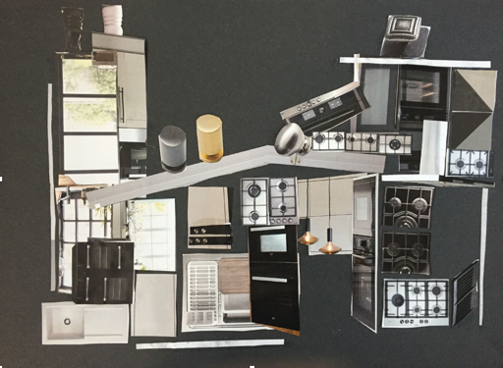  pm: Drawing, mark-making and collage Preparation: Bring an anorak!  - Drawing in the landscape - Alton Estate  - Drawing / collage in the studio  Work in pairs to create:  - an overview of a scheme of work (six lessons) inspired by the built environment  a single lesson plan developed from your scheme of work  - Watch Richard Rogers discuss the Alton Estate here  Recommend Readings (subject):  Boughton, D. and Mason, R. (Eds.) (1999) Beyond Multicultural Art Education: International Perspectives Waxmann Munster: New York  Kraehe, A.M., Gaztambide-Fernández, R. and Carpenter II, B.S. eds., 2018. The Palgrave handbook of Race and the Arts in Education. Springer.  Mason, R. (1995) Art Education and Multiculturalism Corsham: NSEAD  Recommend Reading (CCF):  Rosenshine, B. (2012) Principles of Instruction: Research-based strategies that all teachers should know. American Educator, 12–20. https://doi.org/10.1111/j.1467-8535.2005.00507.x.  PS Links: Race in Education

20/10* | Subject 5:  am: Researching and writing your literature review  Preparation:  Draft a paragraph about your own values for art education and how they relate to the literature on art education  - How can you access further literature to inform your assignment?  - What are the features of effective writing at Masters’ Level?  - What are the conventions for referencing?  pm: Planning and teaching meaningful art and design activities  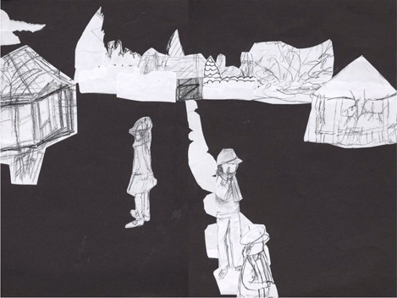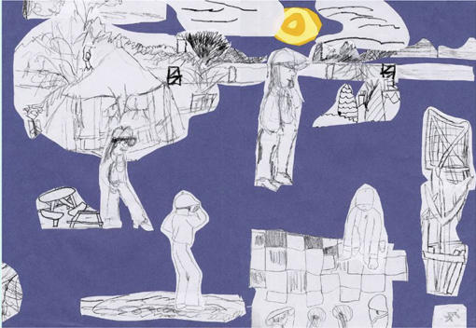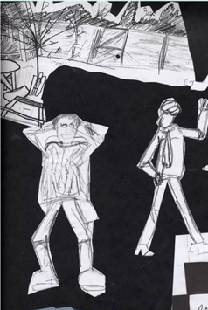  Preparation:  Photograph 2-3 examples of children’s work from your experience in school so far (you need not have taught the lesson). Select examples you think would start interesting discussions.  - Share images of work from your experience in school so far  - What do you find engaging - or problematic - about these images?  - What are the implications for your own planning and teaching?  This is an opportunity for you to share outcomes from your teaching and to reflect on how you might encourage children to develop their work over time.  Recommend Readings (subject):  Addison, N. and Burgess, L. (2014) (Eds.) Learning to Teach Art and Design in the Secondary School: A Companion to School Experience (Third Edition) London: Routledge Falmer (Chapter 3)  PS Links: In school you will be able to start planning and teaching lessons which will consider the complexity of learning and adolescent learners.

10/11 | Subject 6:  am: Reflecting on influences in art and design (Part 1)  Preparation:  Bring one or two images of your own visual work, and one or two images of work that has influenced your thinking about art and design.  - Which artists, craftspeople or designers have influenced your own work?  – How might their work shape your approach to planning and teaching activities in school?  – What are your thoughts on the relationship between you as a learner and you as a teacher?  *There will be enough time for half the group to share images; the second half will share images on 1-12-21.  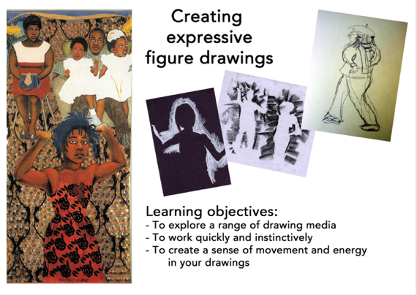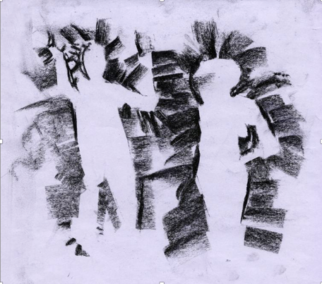  pm: Drawing Take inspiration from one or more artists / craftspeople / designers from BAME backgrounds  - How have these values impacted on your development as an artist/craftsperson/designer in the past?  - How are these values beginning to impact on your teaching of art, craft and design?  - How will you articulate your values in your assignment?  - Writing an introduction and conclusion to your assignment  Recommend Reading (subject):  Bell, J., Balchin, J. and Tobin, C. eds., 2019. Ways of Drawing: Artists' Perspectives and Practices. Thames and Hudson.  Recommend Reading (CCF):  - Davis, P., Florian, L., Ainscow, M., Dyson, A., Farrell, P., Hick, P., Rouse, M. (2004) Teaching Strategies and Approaches for Pupils with Special Educational Needs: A Scoping Study. Accessible from: http://dera.ioe.ac.uk/6059/1/RR516.pdf.  - Education Endowment Foundation (2018) Sutton Trust-Education Endowment Foundation Teaching and Learning Toolkit: Accessible from: https://educationendowmentfoundation.org.uk/evidence-summaries/teaching-learning-toolkit/  PS Links: By examining the links between theory and practice in school you will continue to improve your understanding and ability to plan and teach lessons which consider the complexity of learning and adolescent learners.

24/11* | Subject 7:  am: Writing Part 2 of your assignment – Your own values in art and design  - What are your values in art education?  - How do they relate to those you have read about in the literature?  - How have these values impacted on your development as an artist/craftsperson/designer in the past?  - How are these values beginning to impact on your teaching of art, craft and design?  - How will you articulate your values in your assignment?  - Writing an introduction and conclusion to your assignment  Preparation: Bring one or two images of your own visual work, and one or two images of work that has influenced your thinking about art and design.  pm: Key messages from recent lesson observations  Bring notes on your recent progress in school and be ready to discuss issues arising.  - What challenges do you face in school?  - What are the key messages that emerge from feedback you have received?  - What are your immediate targets?  Recommend Reading (subject):  Addison, N. and Burgess, L. (2014) (Eds.) Learning to Teach Art and Design in the Secondary School: A Companion to School Experience (Third Edition) London: Routledge Falmer (Chapter 2)  Recommend Reading (CCF):  - Agarwal, P. K., Finley, J. R., Rose, N. S., & Roediger, H. L. (2017) Benefits from retrieval practice are greater for students with lower working memory capacity. Memory, 25(6), 764–771.  PS Links: Professionalism, Adaptive teaching

01/12 | Subject 8:  Preparation:  Choose a mathematical pattern as inspiration for exploring printmaking.  am: Printmaking  Developing ideas for sequences of lessons in printmaking  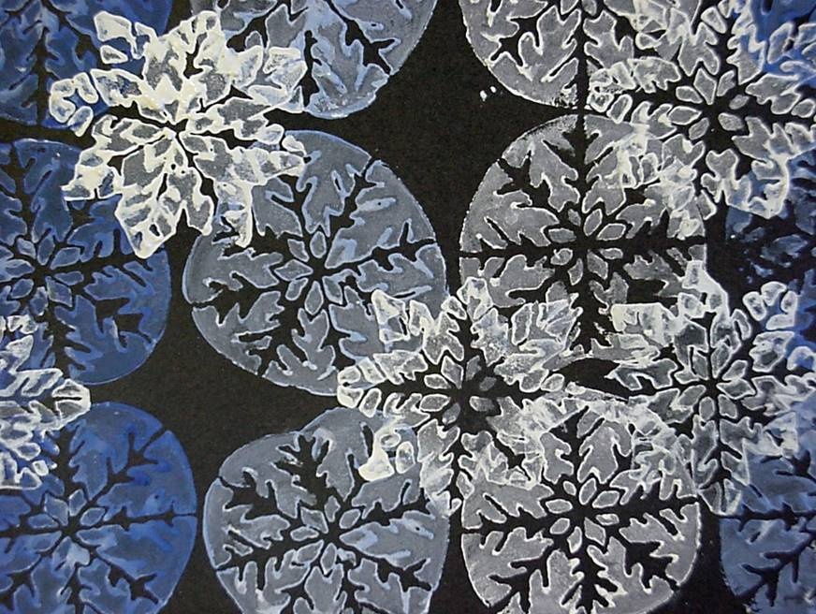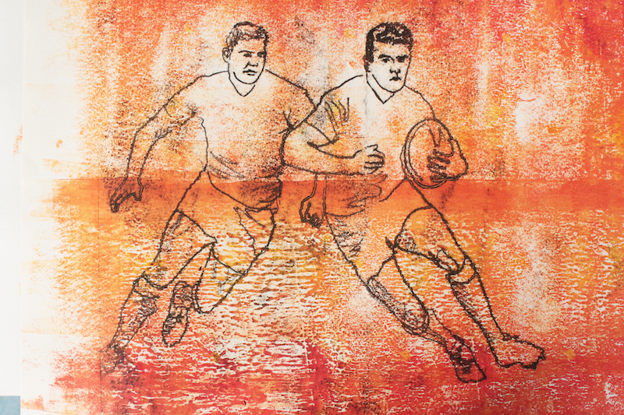  Recommend Reading (subject):  - Watts, R. (2007) Printmaking in Cox, S. and Watts, R. (Eds.) (@007) Teaching Art and Design 3-11 London: Bloomsbury  - The Harmony Project www.theharmonyproject.org.uk  Recommend Reading (CCF):  - Education Endowment Foundation (2016) A marked improvement? A review of the evidence on written marking. Accessible from: https://educationendowmentfoundation.org.uk/public/files/Publications/EEF_Marking_Review_April_2016.pdf.  PS Links: Professionalism, Adaptive teaching

15/12 | Subject 9:  Preparation:  Make initial plans for what to include in a portfolio for your job applications.  am: Assembling a portfolio for interview  - What are the purposes of a portfolio?  - What should you include?  - How should you present your portfolio?  Gathering Evidence  - What evidence have you gathered of your progress towards meeting the Teaching Standards and the Core Curriculum Framework?  Targets for Spring Term teaching  - What are your short-term and medium-term targets for the remainder of your placement?  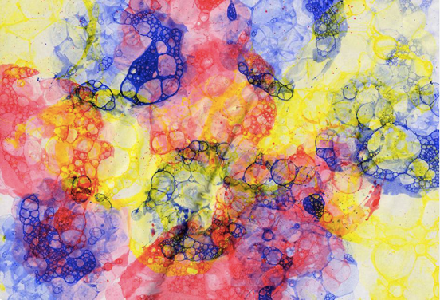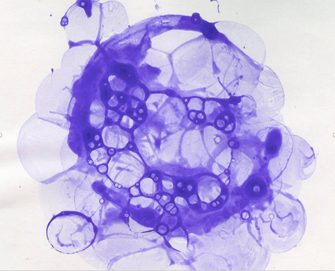  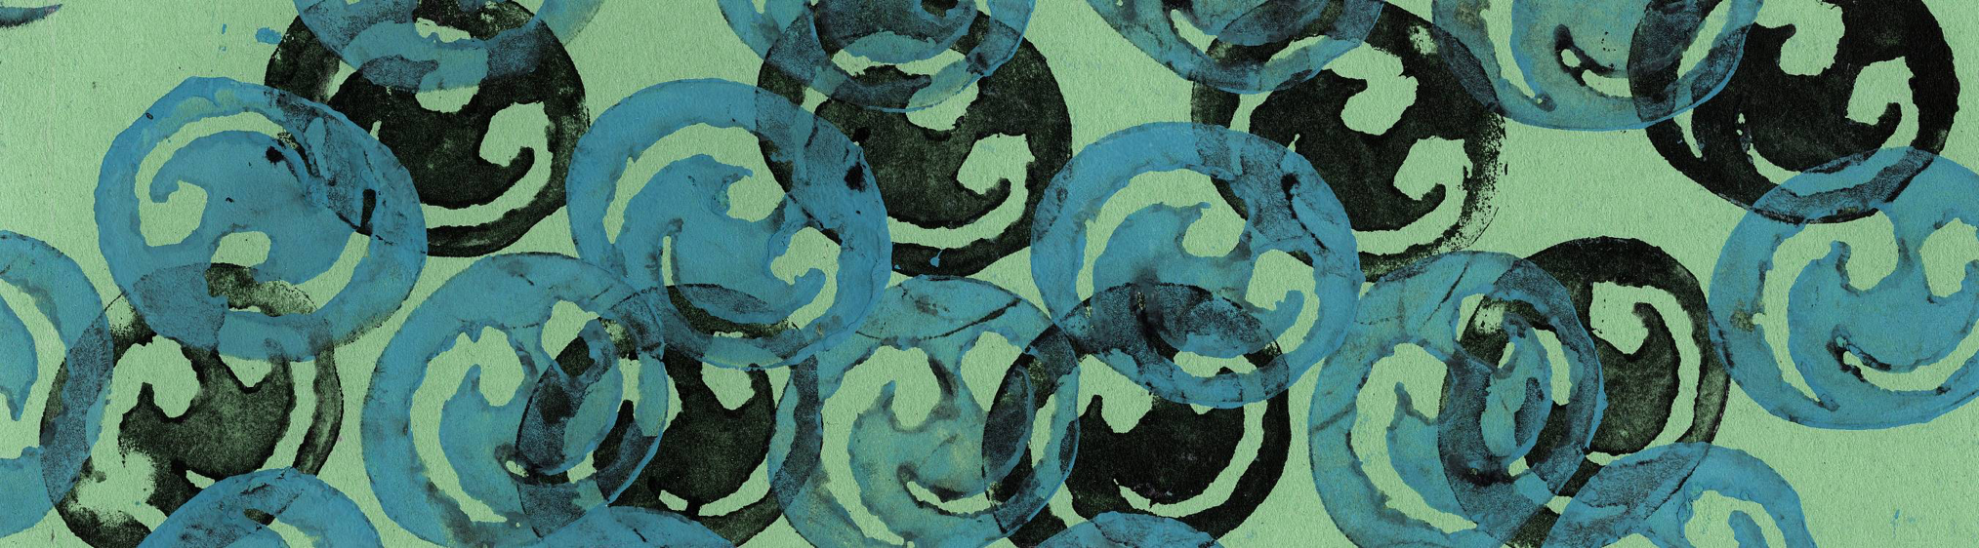  pm: Printmaking 2  Preparation:  Bring inspiration for sequences of lessons in printmaking  - Developing your own ideas for sequences of lessons in printmaking  Recommend Reading (subject):  - Grabowski, B. and Fick, B., 2012. Printmaking: A Complete Guide to Materials & Processes Karakalem Kitabevi Yayınları. Sanat Dizisi  - www.artandeducation.co.uk/printmaking  Recommend Reading (CCF):  Murdock-Perriera, L. A., & Sedlacek, Q. C. (2018) Questioning Pygmalion in the twenty-first century: the formation, transmission, and attributional influence of teacher expectancies. Social Psychology of Education, 21(3), 691–707. https://doi.org/10.1007/s11218-018-9439-9  PS Links:  How to apply for your first Job and get it! Available at: https://www.teachertoolkit.co.uk/2018/05/09/first-teaching-job/
 | Developmental Phase
05/01* | Subject 10:  am Introduction to Assignment 2: Assessment  - How does teacher assessment of children’s work help to improve their knowledge and understanding of Art and Design?  - What are the aims of the assignment?  - What is the structure of the assignment  pm Sculpture  - How can we encourage children to draw inspiration from recycled materials?  - How can we provide opportunities for children to work collaboratively on creative projects?  - What are the essential construction skills for sculpture processes?  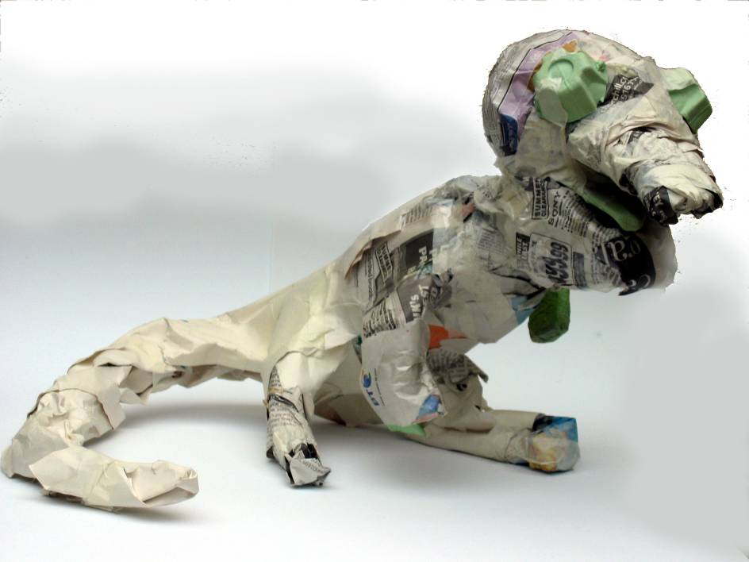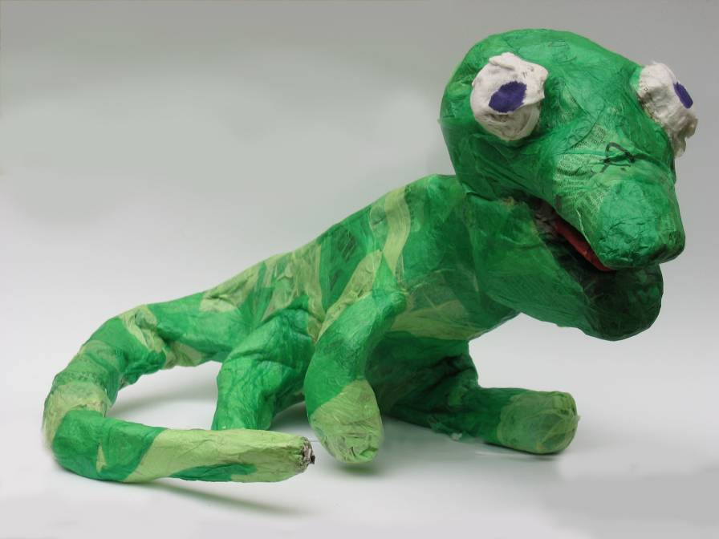  Recommend Reading (subject):  - Rayment, T. (2007) The Problem of Assessment in Art and Design Bristol: Intellect (Chapter 3)  - https://www.artandeducation.co.uk/sculpture  Recommend Reading (CCF):  Rosenshine, B. (2012) Principles of Instruction: Research-based strategies that all teachers should know. American Educator, 12–20. https://www.aft.org//sites/default/files/periodicals/Rosenshine.pdf  PS Links:  Haydn, T., (2013) First do no harm. Capel, S. Leask, M. and Turner, T. Learning to Teach in the Secondary School. 6th ed. London: Routledge, pp.417-438.

19/01 | Subject 11:  am Photoshop  - What is the role of digital technologies in art and design education?  - What are the essential skills students need to learn at Key Stages 3 and 4?  - How can we make meaningful connections between digital technologies and other processes in art and design?  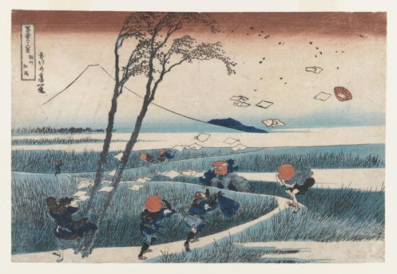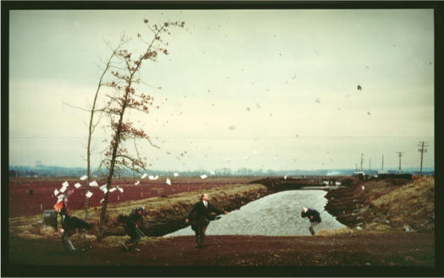  pm Geometry and art and design  - What are the essential skills in geometry that students can learn through art and design?  - How can we create meaningful links between art and design and mathematics?  - How can we develop creative projects that link art and design and geometry?  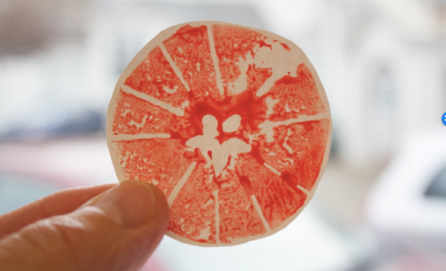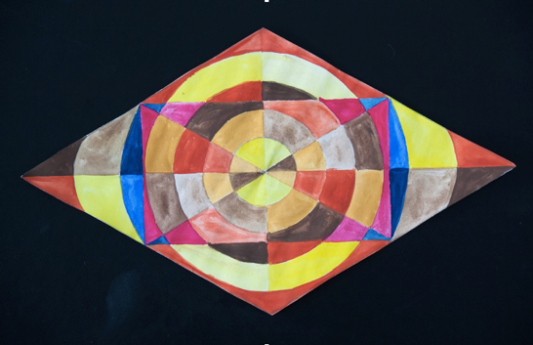  Recommend Reading (subject):  - Collage and Digital Art www.artandeducation.co.uk/collage-digital-art  - The Harmony Project www.theharmonyproject.org.uk  - Winn, D. (2021) Developing links with other subjects in Hardy, A. (Ed) (2021) Learning to Teach Design and Technology in the Secondary School, A companion to School Experience 4th Ed. London: Routledge  Recommend Reading (CCF):  Shanahan, T. (2005) The National Reading Panel Report: Practical Advice for Teachers. Available at: https://files.eric.ed.gov/fulltext/ED489535.pdf p. 18-27  PS Links: Cross Curricular Learning; numeracy; Adaptive teaching & Assessment

09/02* | Subject 12:  Preparation:  Locate a website that you think is an example of effective/innovative design  am Web design  - What makes an effective design for a website?  - How can we use online resources to design a website?  - How can a site become an effective means of gathering and sharing resources related to your teaching experience?  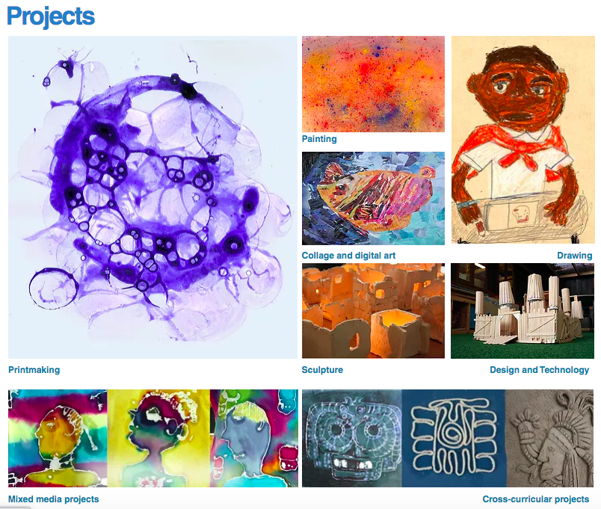  Assessment (2) Richard McPaul  - What are the issues surrounding grading students’ work in art and design?  Recommend Reading (subject):  - Addison, N. and Burgess, L. (2014) (Eds.) Learning to Teach Art and Design in the Secondary School: A Companion to School Experience (Third Edition) London: Routledge Falmer  (Chapter 5)  - Rayment, T. (2007) The Problem of Assessment in Art and Design Bristol: Intellect (Chapter 7)  - Sherwin, D., 2010. Creative workshop: 80 challenges to sharpen your design skills. How Books.  Recommend Reading (CCF):  Hattie, J., & Timperley, H. (2007) The Power of Feedback. Review of Educational Research, 77(1), 81–112. https://doi.org/10.3102/003465430298487  PS Links: Adaptive teaching & Assessment

02/03* | Subject 13:  am Assessment (3) Richard McPaul  - What can we learn from exploring recent examples of student work in art and design at GCSE and A Level?  - What are the issues surrounding making judgments leading to examinations ?  pm Graphic Design  - What is the values of graphic design in the art and design curriculum??  - How can art teachers use graphic design to raise levels of engagement with the subject?  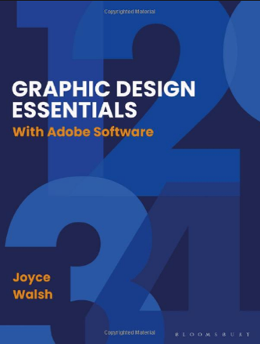  Recommend Reading (subject):  - Eisner, E. W. (2004) The Arts and the Creation of Mind New Haven: Yale University Press  (Chapter 7)  - Eskilson, S.J., (2019). Graphic Design: A New History. Yale University Press  - Haydn, T. (2016) Assessment, pupil motivation and learning, in Capel, S., Leask, M. and Turner, T (eds) Learning to Teach in the Secondary School: A Companion to School Experience, Abingdon, Oxon: Routledge 927-974  - Walsh, J. (2020) Graphic Design Essentials with Adobe software (Second Edition) London: Bloomsbury  Recommend Reading (CCF):  Wiliam, D. (2017) Assessment, marking and feedback. In Hendrick, C. and McPherson, R. (Eds.) What Does This Look Like in the Classroom? Bridging the gap between research and practice. Woodbridge: John Catt.  PS Links:  PISA (2015) PISA in Focus: Do teacher-student relations affect students’ well-being at school? Accessible from: https://doi.org/10.1787/22260919.

 | Consolidation Phase
09/03 | Subject 14:  am Beauty and aesthetics in art education / Modernism and Postmodernism in art education  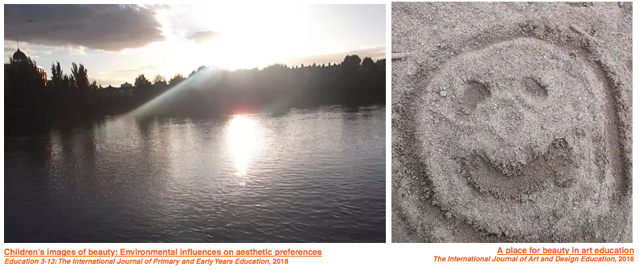  pm Textiles  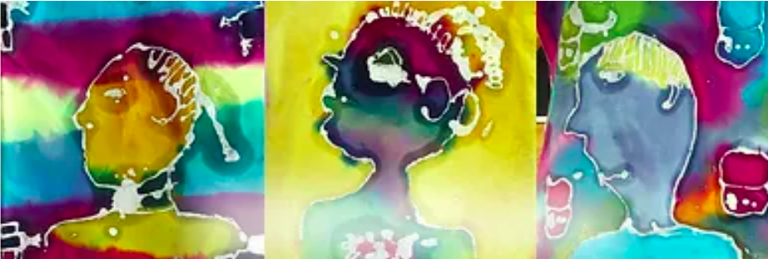  Recommend Reading (subject)  Danto, A.C. (2003) The Abuse of Beauty: Aesthetics and the Concept of Art Chicago and LaSalle: Open Court  Emery, L. (2002) (Ed) Teaching Art in a Postmodern World Altona, Australia: Common Ground Publishing  Hardy, T. (2006) Art Education in a Postmodern World Bristol: Intellect  Watts, R. (2018) A Place for Beauty in Art Education available here  Watts, R. (2019) Children’s images of beauty: environmental influences on aesthetic preferences available here  Winston, J. (2010) Beauty and Education London: Routledge  Recommend Reading (CCF):  Kirschner, P., Sweller, J., Kirschner, F. & Zambrano, J. (2018) From cognitive load theory to collaborative cognitive load theory. In International Journal of Computer-Supported Collaborative Learning, 13(2), 213-233.  PS Links: Professionalism (Wellbeing) Learning and memory

23/03 | Subject 15:  Ceramics Sarah Llewelyn-Williams  Exploring a range of ceramics processes with ceramicist teacher Sarah Llewelyn-Williams  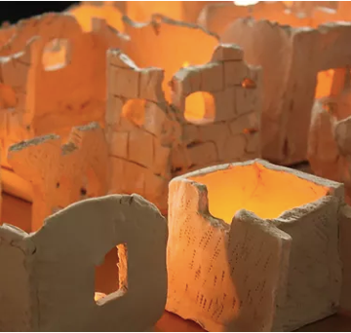  Recommend Reading (subject):  www.artandeducation.co.uk/sculpture  Recommend Reading (CCF):  Higashida, N. (2013). The Reason I Jump: one boy's voice from the silence of autism Hachette UK  Recommended from the CCF  Department for Education (2018) Schools: guide to the 0 to 25 SEND code of practice. Available at Advice template (publishing.service.gov.uk)  PS Links: SEND; Adaptive teaching

20/04 | Subject 16:  Sculpture Alistair Lambert  Exploring sculpture processes with artist/ teacher Alistair Lambert  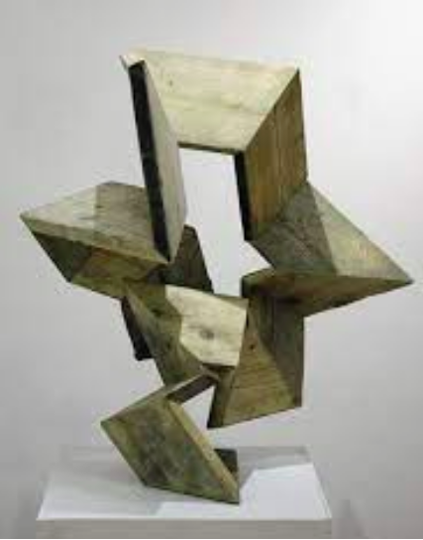  Recommend Reading (subject):  Gormley, A. and Gayford, M. (2019) Shaping the World: Sculpture from Prehistory to Now London: Thames and Hudson  www.alistairlambert.co.uk  www.artandeducation.co.uk/sculpture  Recommend Reading (CCF):  Johnson, S. K., Buckingham, M. H., Morris, S. L., Suzuki, S., Weiner, M. B., Hershberg, R. M.,& Lerner, R. M. (2016). Adolescents’ character role models: Exploring who young people look up to as examples of how to be a good person. Research in Human Development, 13(2), 126-141.  PS Links: Professionalism (Wellbeing) Learning and memory

27/04 | Subject 17: Harmony Richard Dunne and Lisa Atkinson

08/06 | Subject 18:  am Children’s visual culture Alastair Daniel and Susan Ogier  - What is the value of drawing inspiration from children’s visual culture?  - How can art teachers use children’s book illustration to raise levels of engagement with the subject?  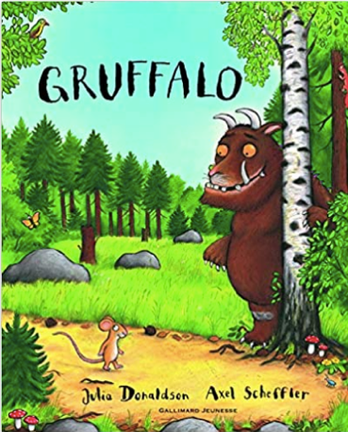  pm Presentations from last year’s PGCE students  Illustration  - What are the characteristics of teaching and learning illustration skills?  - How can art teachers make connections with children’s learning in literacy?  Recommend Reading (subject):  Duncum, P. (2020) Picture Pedagogy: Visual Culture Concepts to Enhance the Curriculum London: Bloomsbury  Rivers, C. (2011) Handmade Type Workshop London: Thames and Hudson  Ball, D. L., Thames, M. H., & Phelps, G. (2008) Content knowledge for teachers: What makes it special? Journal of Teacher Education, 2008 59: 389 DOI: 10.1177/0022487108324554 [Online] Accessible from: https://www.math.ksu.edu/~bennett/onlinehw/qcenter/ballmkt.pdf.  Recommend Reading (CCF):  Shanahan, T. (2005) The National Reading Panel Report: Practical Advice for Teachers. Accessible from: https://files.eric.ed.gov/fulltext/ED489535.pdf p. 18-27  Education Endowment Foundation (2018) Preparing for Literacy Guidance Report. [Online] Accessible from: https://educationendowmentfoundation.org.uk/public/files/Preparing_Literacy_Guidance_2018.pdf  PS Links: Cross Curricular Learning; Literacy

22/06 | Subject 19:  am Museum and Gallery Education (visit to Tate Britain / Victoria and Albert Museum)  - What is the rationale for museum and gallery education?  - What are effective strategies for engaging children and young people with museum and gallery collections?  - What are the barriers facing children and young people when engaging with art, design and culture?  pm Photography  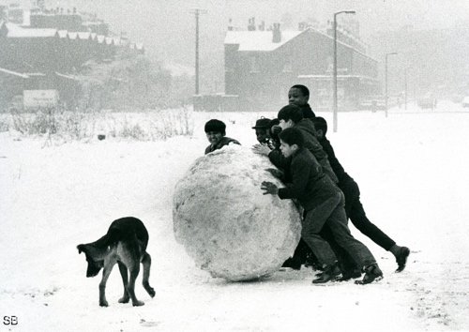  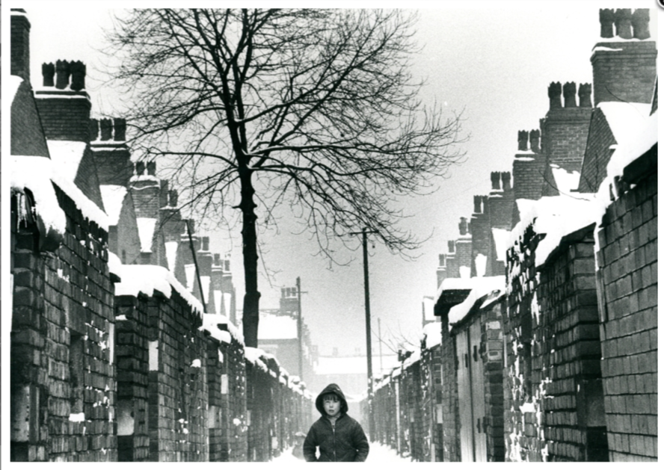  - What is the place of photography within the art and design curriculum?  - What is nature of the changing role of photography in children’s lives?  - How can teachers of art and design use photography to raise children’s levels of engagement with the visual world?  Recommend Reading (subject):  - Hickman, R. (Ed.) (2005) Critical Studies in Art and Design Education Bristol: Intellect  - Hooper-Greenhill, E. (2000). Museums and the Interpretation of Visual Culture. London, Routledge  - Baker, S. (2018) Without a Trace: Manchester and Salford in the 1960s The History Press (www.shirleybakerphotography.com)  - The Photographers’ Gallery www.thephotographersgallery.org.uk  Recommend Reading (CCF):  Shanahan, T. (2005) The National Reading Panel Report: Practical Advice for Teachers. Accessible from: https://files.eric.ed.gov/fulltext/ED489535.pdf p. 18-27  PS Links: Professionalism (Wellbeing) Learning and memory

29/06 | Subject 20: Beginning your career in teaching / Revisiting principles for teaching and learning in art and design / EXIT Survey /  Reflections on outcomes in school  Reading:  Department of Education (2019) Early Career Framework Available at: https://assets.publishing.service.gov.uk/government/uploads/system/uploads/attachment_data/file/773705/Early-Career_Framework.pdf  Recommend Reading (CCF):  Skaalvik, E. M., & Skaalvik, S. (2017) Still motivated to teach? A study of school context variables, stress and job satisfaction among teachers in senior high school. Social Psychology of Education, 20(1), 15–37.  PS Links: Professionalism (Wellbeing) Learning and memory  Reflections on outcomes in school  Recommend Reading (subject):  Watts, R. (in press) Values, influences, identities : Reflecting on principles for teaching and learning in art and design

Bibliography

There are a wide range of publications on Art and Design that can be accessed in the Library either in hard copy or digital version and via Moodle resource lists; the list below is guidance on useful reading for your assignments and preparation for your teaching blocks. This is not an exhaustive list and other books may be referred to during the year.

Essential texts

Addison, N. and Burgess, L. (2014) (Eds.) Learning to Teach Art and Design in the Secondary School: A Companion to School Experience (Third Edition) London: Routledge Falmer

Eisner, E. W. (2004) The Arts and the Creation of Mind New Haven: Yale University Press

Hickman, R. (2005) Why we make art and why it is taught Bristol: Intellect

Recent overviews

Addison, N., Burgess, L. Steers, J. and Trowell, J. (2010) Understanding Art Education: Engaging Reflexively with Practice London: Routledge Falmer

Atkinson, D. And Dash, P. (2005) Social and Critical Practices in Art Education (Landscapes: The Arts, Aesthetics, and Education) London: Trentham Books

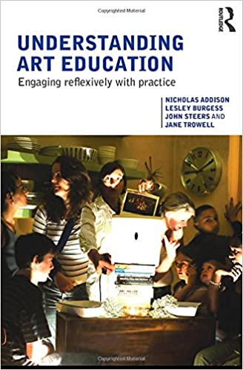
Emery, L. (2002) (Ed) Teaching Art in a Postmodern World Altona, Australia: Common Ground Publishing

Hardy, T. (2006) Art Education in a Postmodern World Bristol: Intellect

Herne, S., Cox, S. and Watts, R. (2009) Readings in Primary Art Education Bristol: Intellect

Hickman, R. (2004) (Ed.) Art Education 11-18: Meaning, Purpose and Direction (Second Edition) London: Continuum

Rayment, T. (2007) The Problem of Assessment in Art and Design Bristol: Intellect

Romans, M. (Ed) (2005) Histories of Art and Design Education: Collected Essays Bristol: Intellect

Sullivan, G. (2012) Art Practice as Research: Inquiry in Visual Arts London: Sage

Creativity

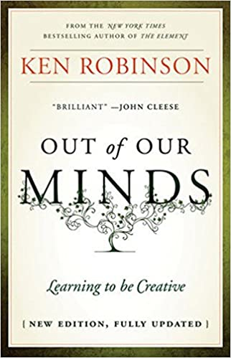
Craft, A. (2005) Creativity in Schools: Tensions and Dilemmas Oxford: Routledge

Csikszentmihalyi, M. (1997) Creativity: Flow and the psychology of discovery and invention New York: Harper Perennial.

Fisher, R. and Williams, M. (2004) Unlocking Creativity: A Teacher's Guide to Creativity Across the Curriculum London: David Fulton

Mcintosh, P. and Warren, D. (2012) Creativity in the Classroom: Case Studies in Using the Arts in Teaching and Learning in Higher Education Bristol: Intellect

Robinson, K. (2001) Out of Our Minds: Learning to be Creative Oxford: Capstone.
Robinson, K. (2016) Creative Schools: Revolutionizing Education from the Ground Up London: Penguin

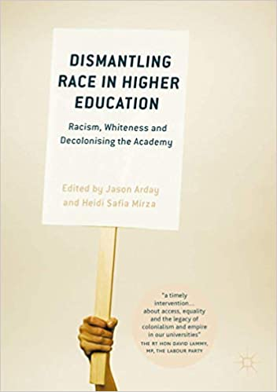
Multiculturalism

Arday, J. and Mirza, H.S. eds., 2018. Dismantling race in higher education: Racism, whiteness and decolonising the academy. Springer.

Eca, T. and Mason, R. (2009) International Dialogues About Visual Culture, Education and Art Bristol: Intellect

Mason, R. (1995) Art Education and Multiculturalism Corsham: NSEAD

Boughton, D. and Mason, R. (Eds.) (1999) Beyond Multicultural Art Education: International Perspectives Waxmann Munster: New York

Kraehe, A.M., Gaztambide-Fernández, R. and Carpenter II, B.S. eds., 2018. The Palgrave handbook of race and the arts in education. Springer.

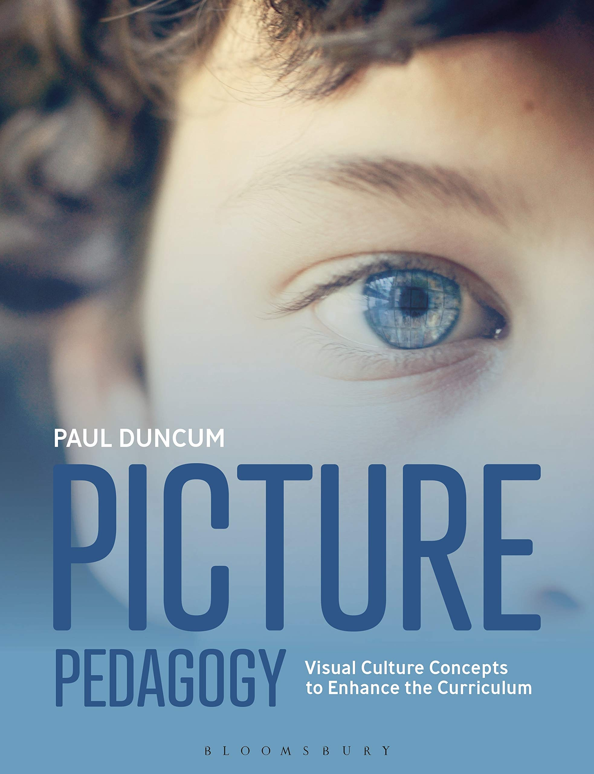
Visual culture

Duncum, P. (2020) Picture Pedagogy: Visual Culture Concepts to Enhance the Curriculum London: Bloomsbury

Freedman, K. (2003). Teaching visual culture: Curriculum, aesthetics, and the social life of art. New York & Reston, VA: Teacher’s College Press & the National Art Education Association.

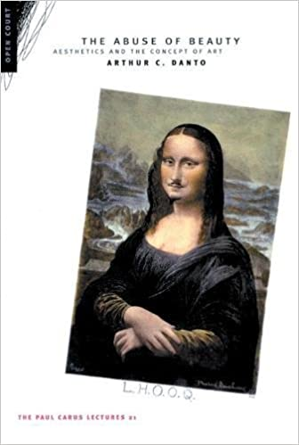
Aesthetics
Danto, A.C. (2003) The Abuse of Beauty: Aesthetics and the Concept of Art Chicago and LaSalle: Open Court

Winston, J. (2010) Beauty and Education London: Routledge

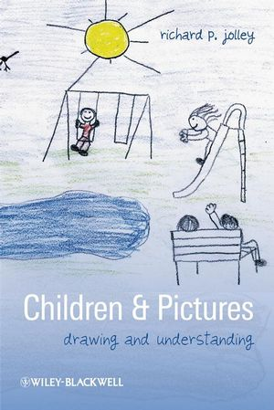
Children’s drawings

Anning, A., K. Ring. 2004. Making Sense of Children’s Drawings. Maidenhead: Open University Press

Garner, S. (2008) Writing on Drawing: Essays on Drawing Practice and Research Bristol: Intellect

Jolley, R. (2009) Children and Pictures Oxford: Wiley-Blackwell

Matthews, J. (2003) Drawing and Painting: Children and Visual Representation (Second Edition). London: Paul Chapman

Willats. J. 2005. Making Sense of Children’s Drawings. Mahwah, N.J.: L. Erlbaum Associates

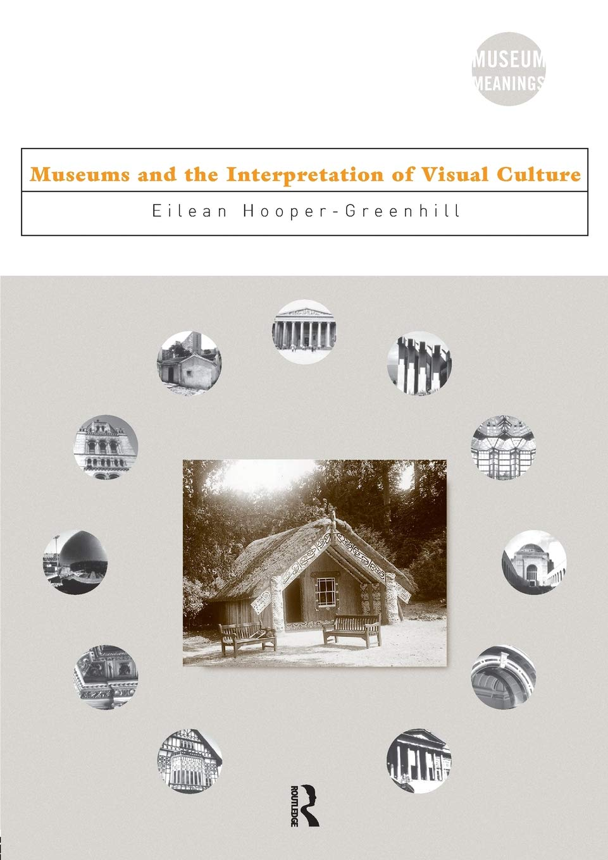
Museum and Gallery Education / Using artists’ work in education

Hickman, R. (Ed.) (2005) Critical Studies in Art and Design Education Bristol: Intellect

Hooper-Greenhill, E. (2000). Museums and the Interpretation of Visual Culture. London, Routledge

Taylor, R. (1986) Educating for Art London: Longman

Thistlewood, D. (1989) (Ed.) Critical Studies in Art and Design Education. London: Heinemann

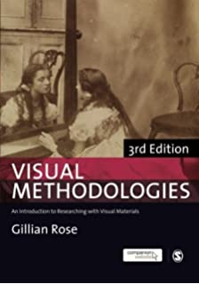
Research methodology

Banks, M. (2001) Visual Methods in Social Research London: Sage

Cohen, L., Manion, L. and Morrison, K. (2007) Research Methods in Education (Sixth Edition) London: Routledge

Denscombe, M. (2010) The Good Research Guide: for small-scale social research projects Open University Press

Hickman, R. (Ed.) (2008) Research in Art & Design Education: Issues and Exemplars Bristol: Intellect

Newby, P. (2009) Research Methods for Education London: Longman

Rose, G. (2013) Visual Methodologies (Third Edition) London: Sage

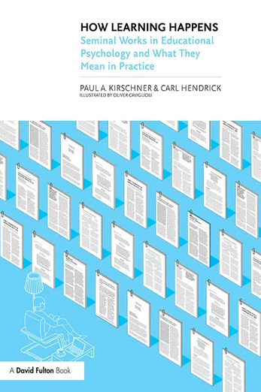
Pedagogical Issues

Kyriacou, C. (2009)
Effective Teaching in Schools: Theory and
Practice (Third Edition)
London: Nelson Thornes

Pollard, A. (Ed.) (2002)
Readings for Reflective Teaching
London: Continuum

Pollard, A. (2008).
Reflective Teaching (Third Edition).
London: Continuum

Kirschner, P.A. and Hendrick, C., (2020.)
How learning happens: Seminal works in
educational psychology and what they mean in practice.
Routledge.

Practical processes

Bell, J., Balchin, J. and Tobin, C. eds., 2019. Ways of Drawing: Artists' Perspectives and Practices. Thames and Hudson.

Eskilson, S.J., 2019. Graphic Design: A New History. Yale University Press.

Grabowski, B. and Fick, B., 2012. Printmaking: A Complete Guide to Materials & Processes Karakalem Kitabevi Yayınları. Sanat Dizisi.

Sherwin, D., 2010. Creative workshop: 80 challenges to sharpen your design skills. How Books.

Walsh, J. (2020) Graphic Design Essentials with Adobe software (Second Edition) London: Bloomsbury

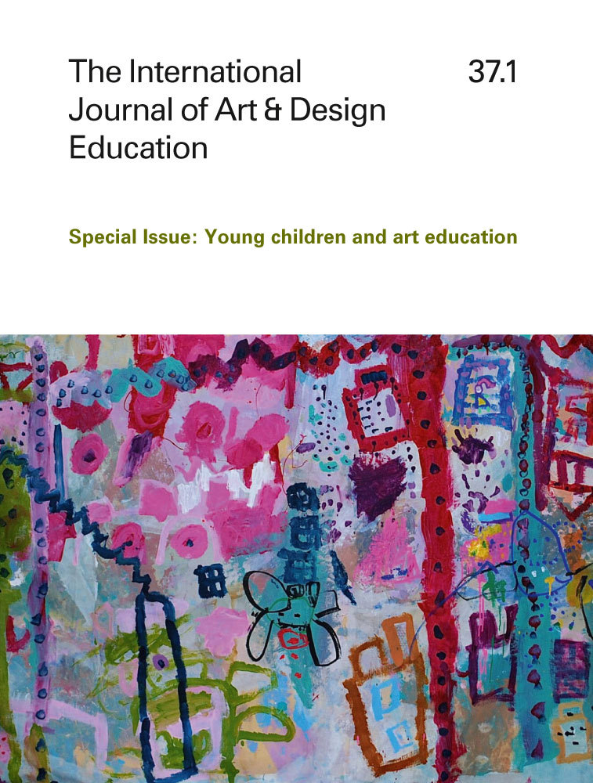

Journals

International Journal of Art and Design Education
https://onlinelibrary.wiley.com/journal/14768070

Art Education
http://www.arteducators.org/research/art-education

Studies in Art Education
http://www.arteducators.org/research/studies

Websites

www.artandeducation.co.uk

ArtandEducation is designed by course tutor Robert Watts to inspire teachers, student teachers and art educators to enjoy investigating, making and thinking about art in schools. The site features over 100 resources that are free to download. There are projects aimed at inspiring children's creativity and articles on teaching and learning, as well as links to books on art education and a selection of recent research in the area.

Although the site is designed principally for primary teachers, secondary students are strongly advised to look closely at the site as it contains a range of resources that can easily be adapted for teaching and learning at Key Stages 3 and 4.
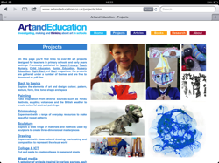
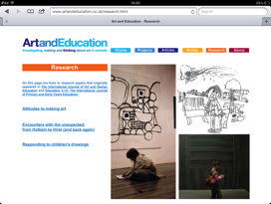
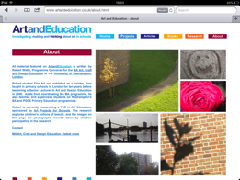
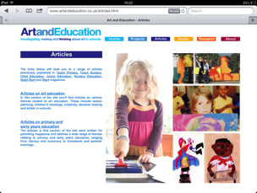
Museums and galleries

Barbican www.barbican.org.uk
British Museum www.britishmuseum.org
Contemporary Applied Arts www.caa.org.uk
Design Museum www.designmuseum.org
Hayward Gallery www.southbankcentre.co.uk/venues/hayward-gallery
Institute of Contemporary Art www.ica.art
National Gallery www.nationalgallery.org.uk
National Portrait Gallery www.npg.org.uk
Photographers’ Gallery www.thephotographersgallery.org.uk
Royal Academy of Arts www.royalacademy.org.uk
Saatchi Gallery www.saatchi-gallery.co.uk
Serpentine Gallery www.serpentinegalleries.org
South London Gallery www.southlondongallery.org
Tate www.tate.org.uk
Victoria and Albert Museum www.vam.ac.uk
Whitechapel Gallery www.whitechapel.org

Suppliers of art materials to schools

GLS www.glsed.co.uk
Rapid www.rapidonline.com
Technology Supplies www.technologysupplies.co.uk
Seawhites www.seawhite.co.uk

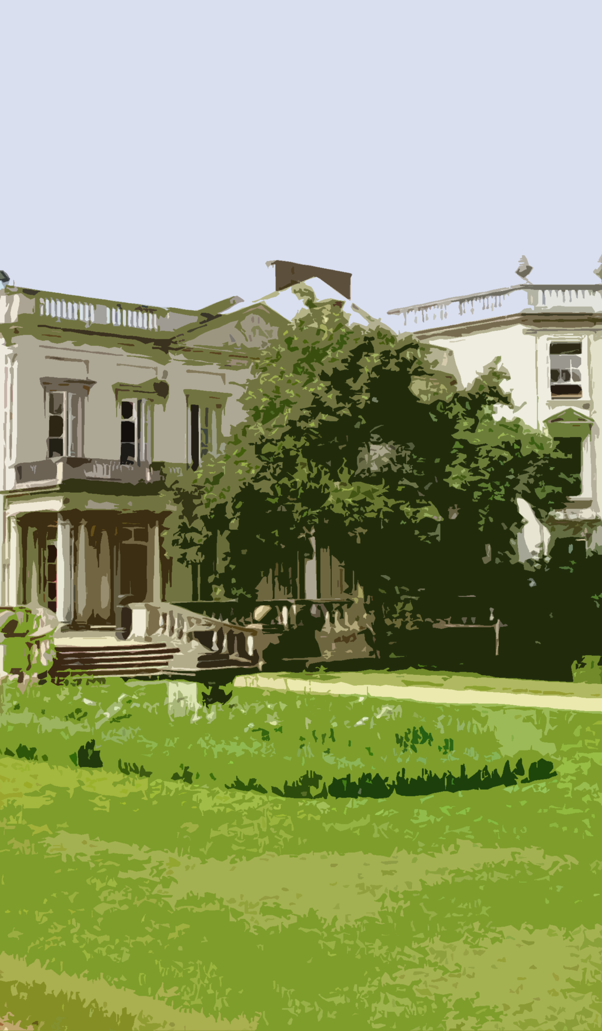

‘A Froebelian approach to teacher development, with the pastoral and learning needs of the whole child’.

